The very first look of Postgres as below.

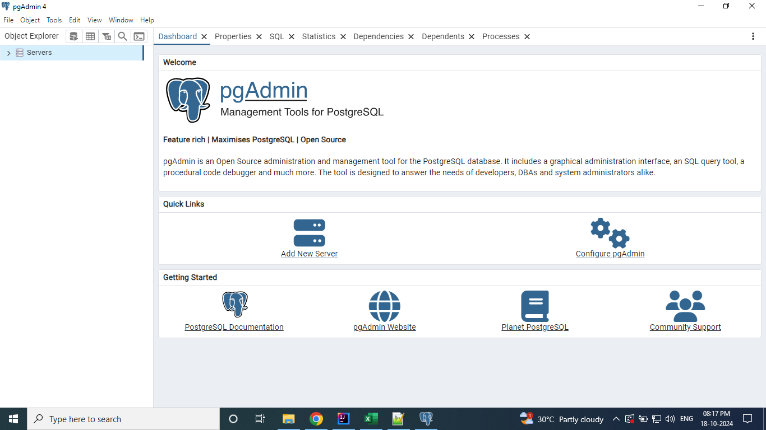

When you click on Servers. You will be prompted for the password provided during the installation.

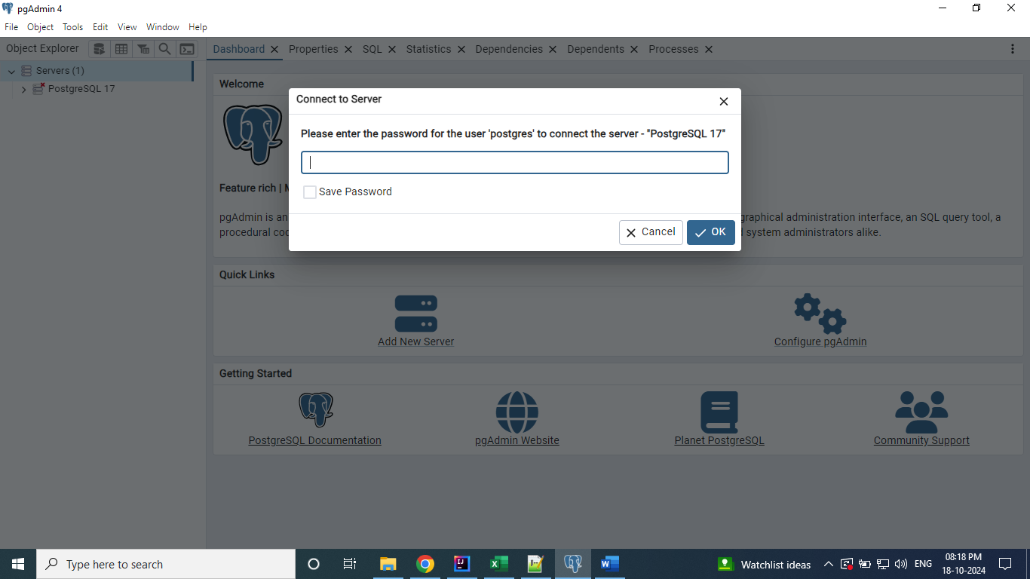

Enter the password and click Ok.

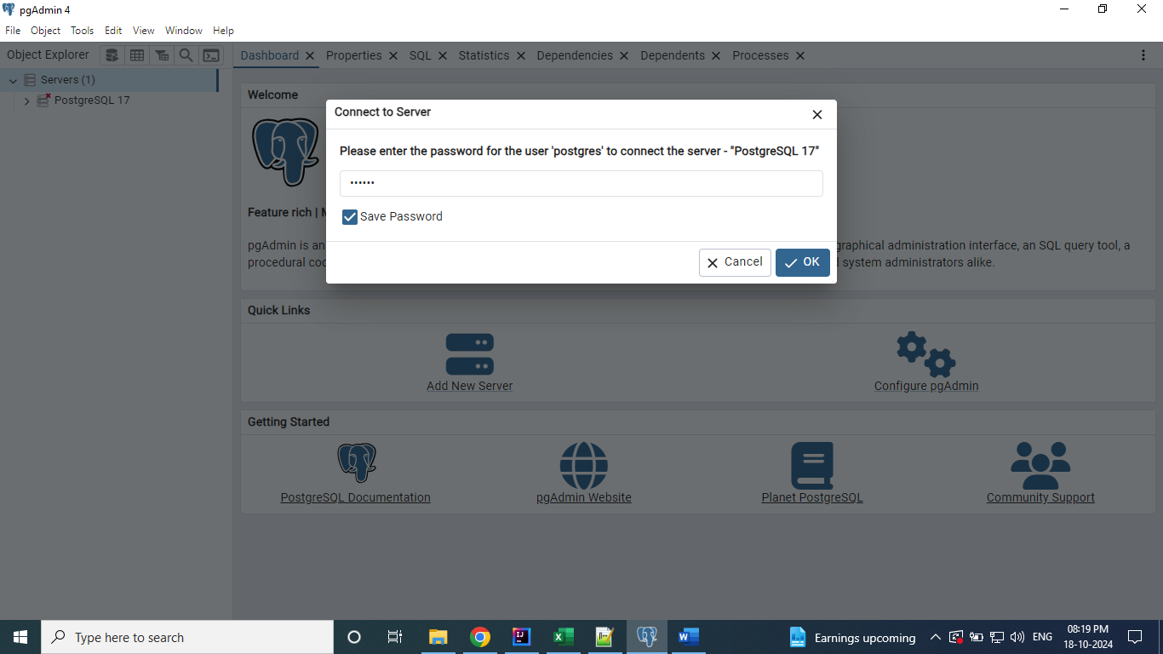

After click on Ok. The screen looks like below. It has default Database.

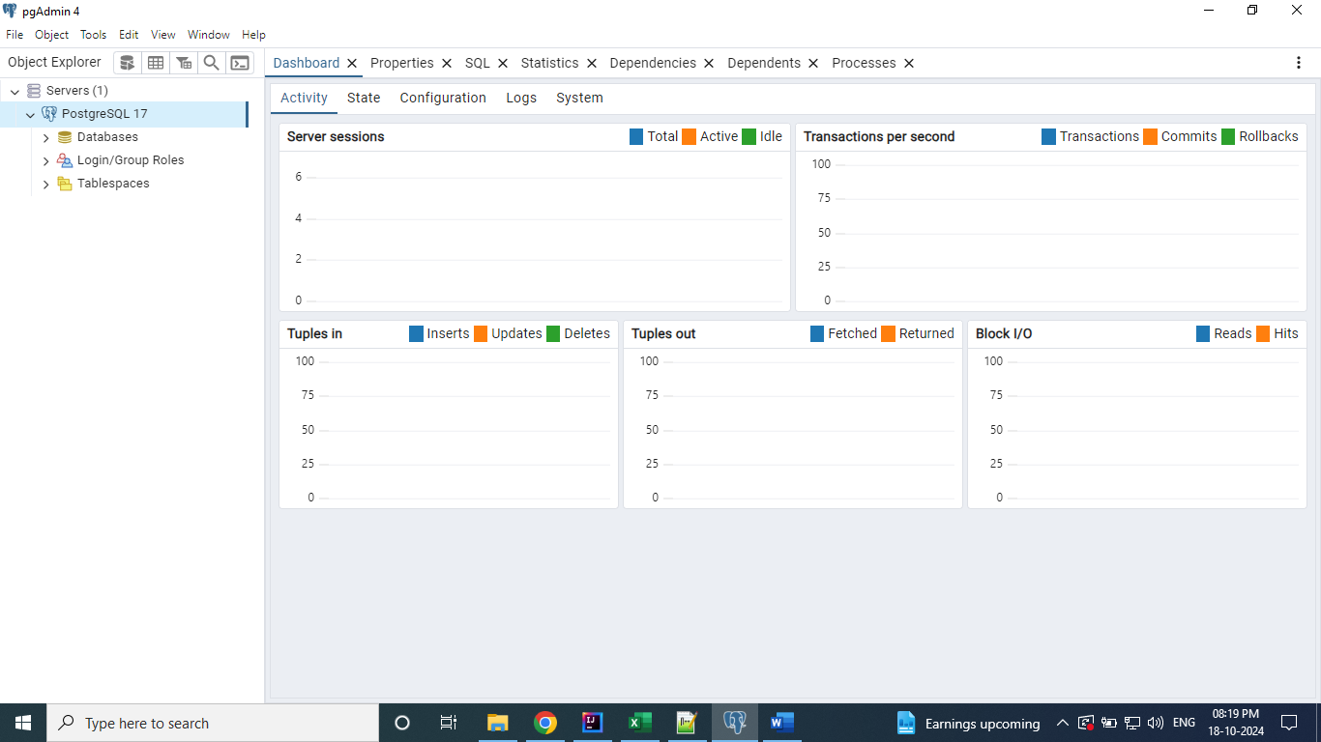

Right click on Database and select Query Tool.

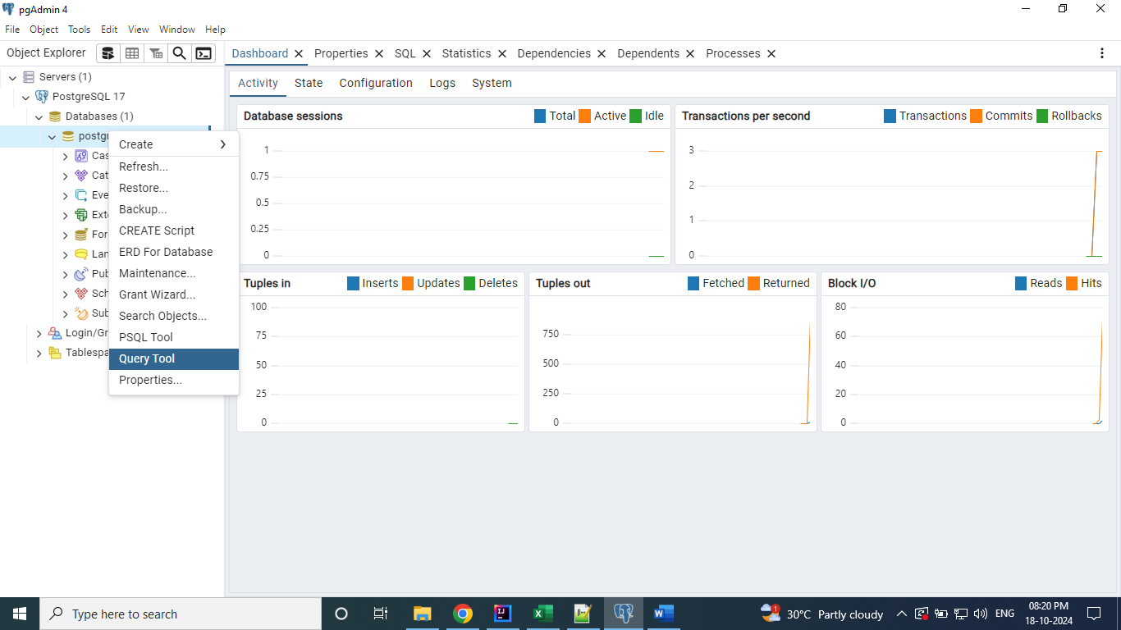

Query Tool Looks like below.

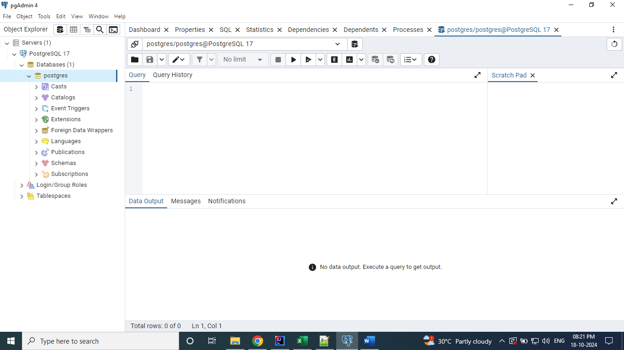

Executed the below query to know the tables details available on the default Database.

**Select * from information_schema.tables;**

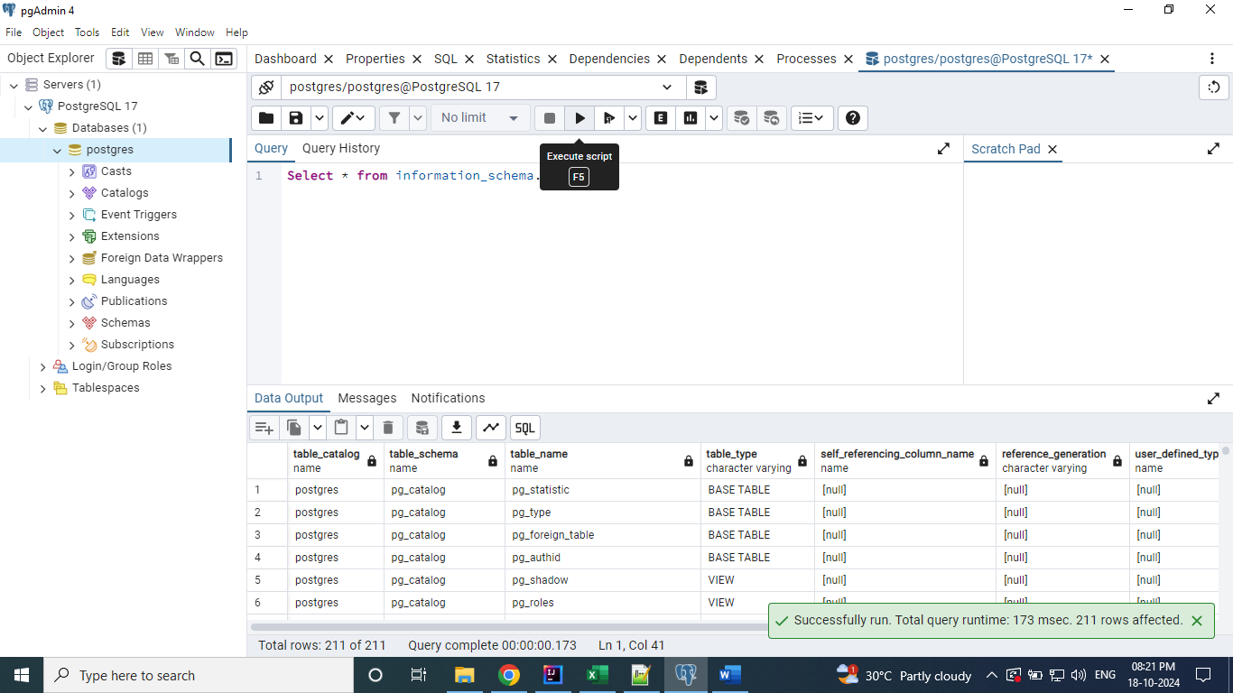

Have created the new Database with name “demo”

**Create database demo;**

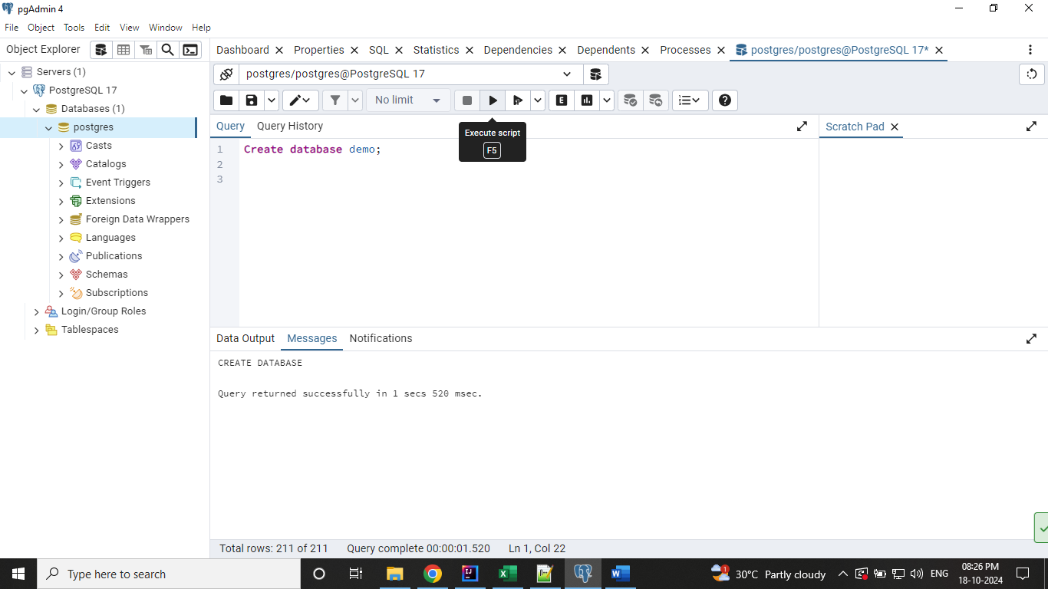

Right click on the Databases and click on Refresh to see the newly created Database.

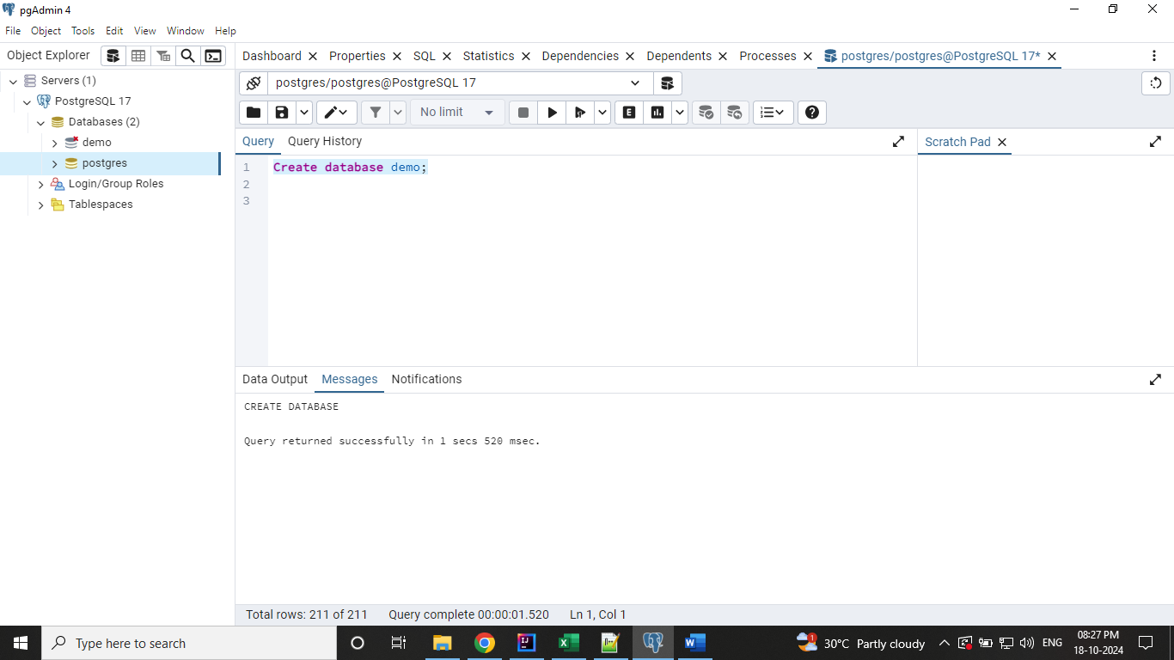

By default, the connection to the new Database is not established. You can click on it, then the connection will be established and the ‘x’ mark will be removed.

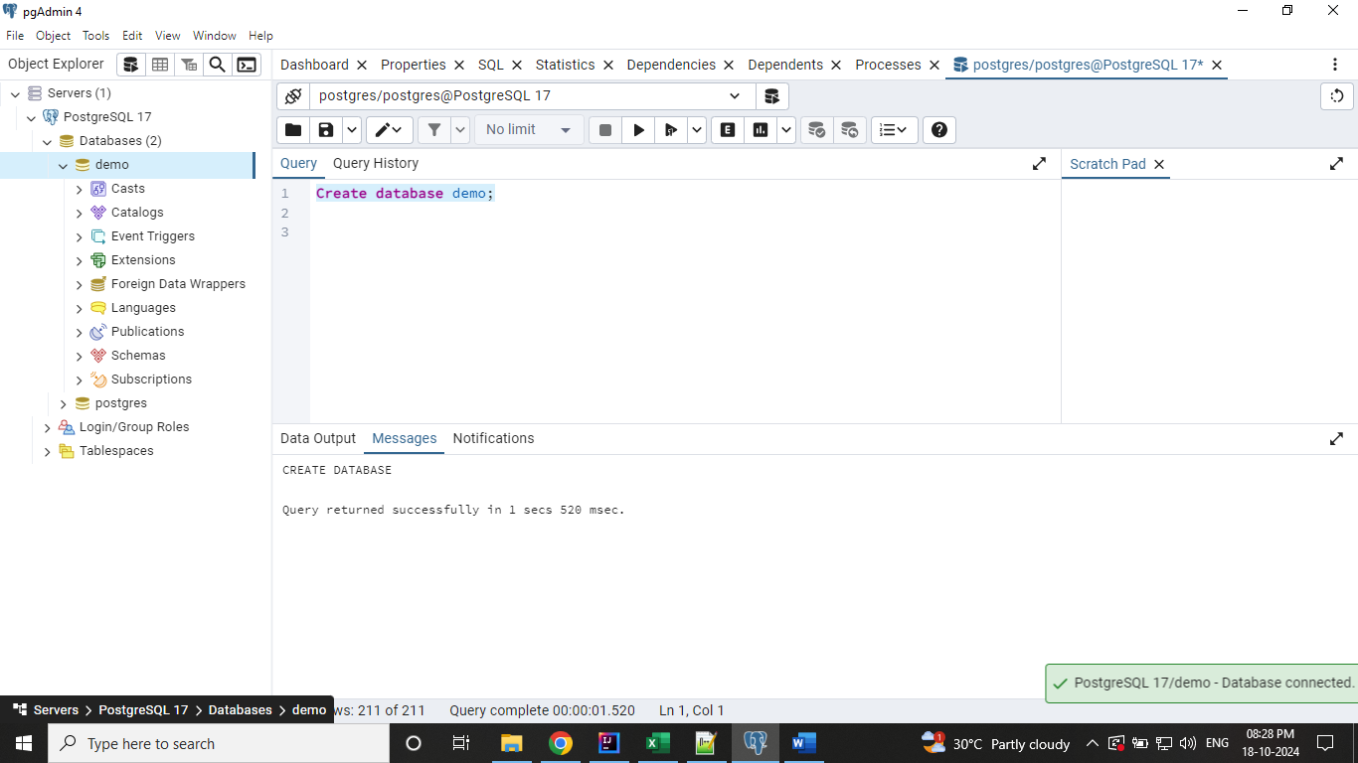

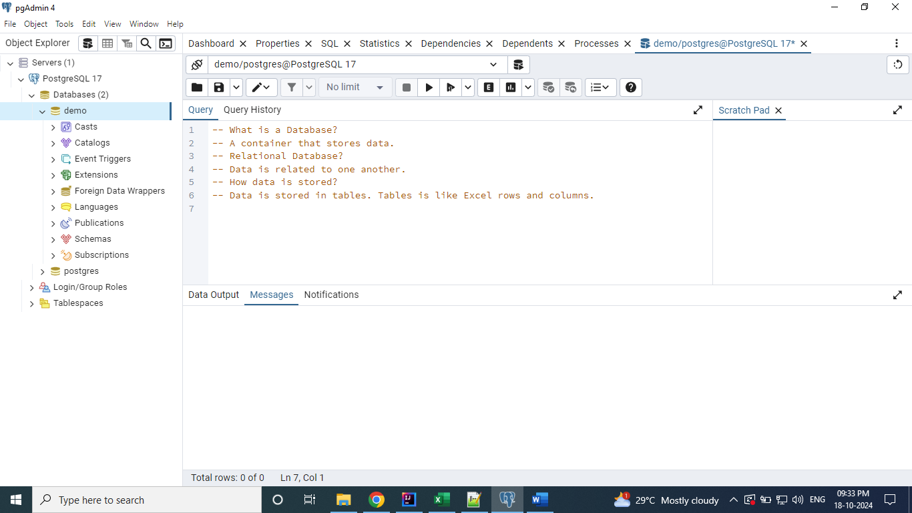

Created a table with name “Products” on the demo database.

**create table products (**

**product_code int,**

**product_name varchar(50),**

**price float,**

**released_date date**

**);**

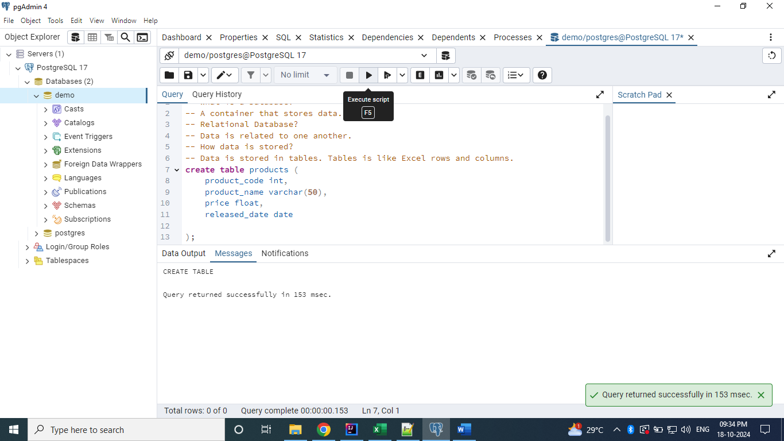

Query the created table.

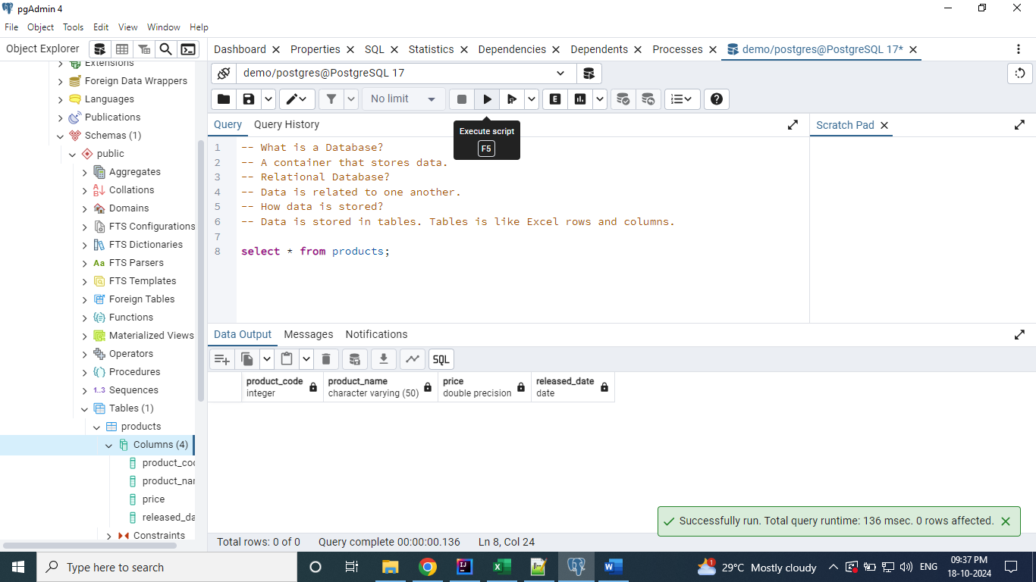

We can add the data into the table as below.

**insert into products (product_code, product_name, price, released_date)**

**values (1, 'Samsung M04', 999.5, to_date('25-07-2022', 'dd-mm-yyyy'));**

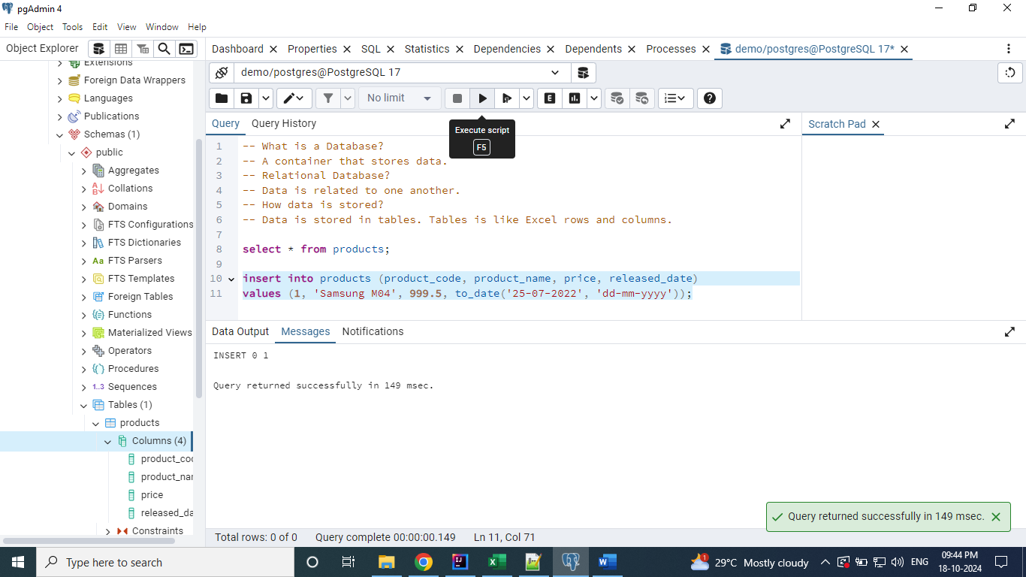

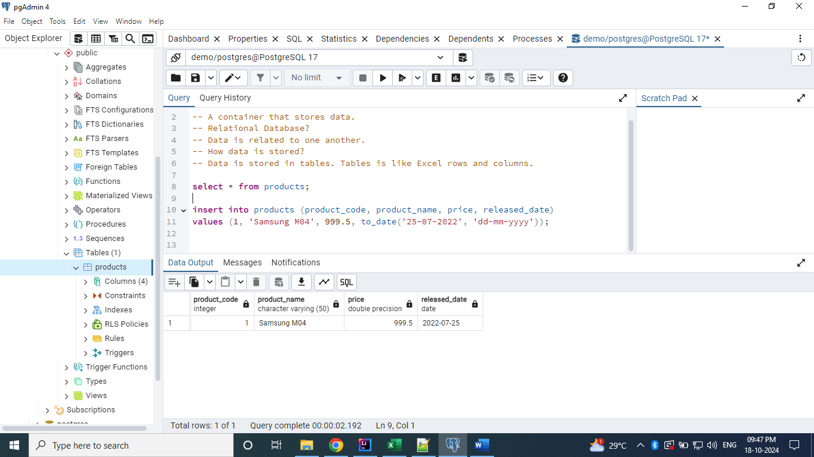

Fetch the records from Product table based on price whose value is greater than 1000.

**Select * from Products where price > 1000;**

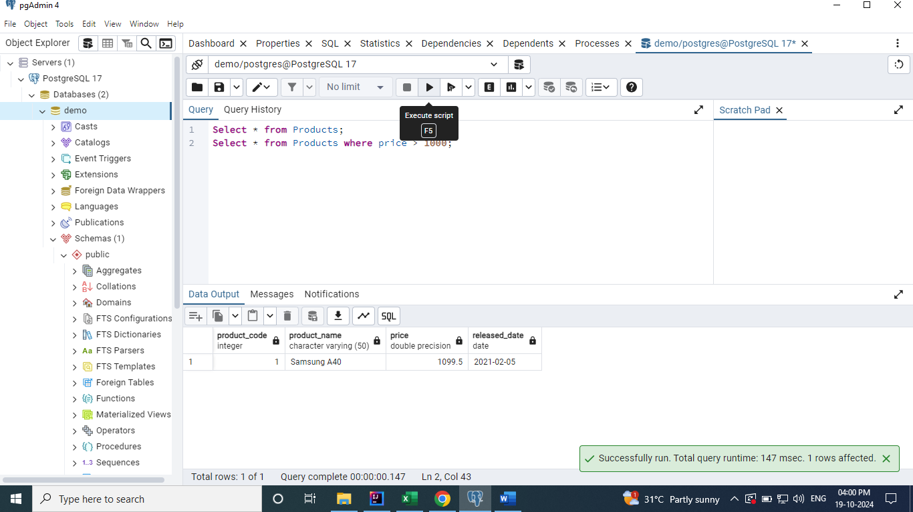

Fetch the records based on the year. Here, the released_date column is of type ‘date’ and when

We query using the value year as ‘2022’ it will throw an error. So, we need to typecast / convert the

released_date column to varchar type using the to_char function.

**Select * from Products where to_char(released_date, 'yyyy') = '2022';**

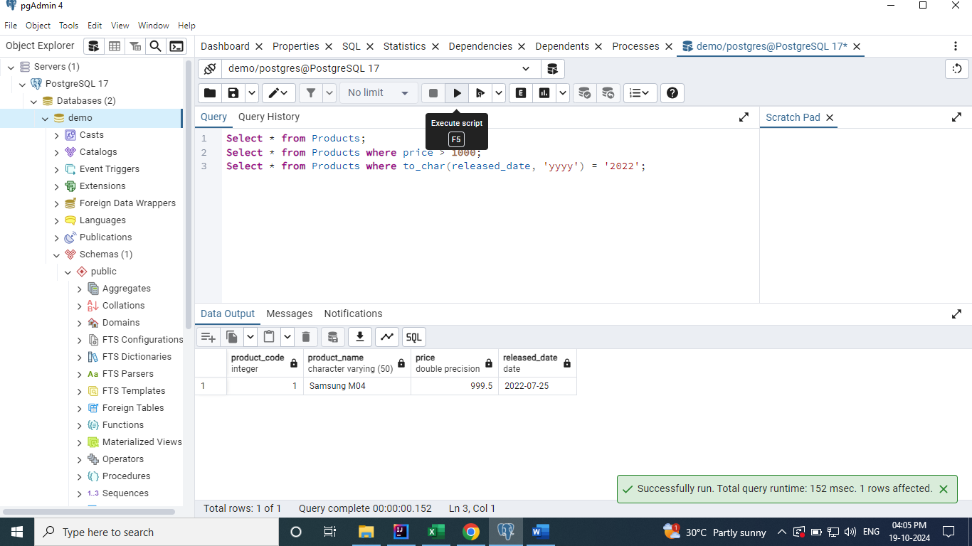

The above result can be retrieved using the Postgres SQL’s specific function called extract.

**Select * from Products where extract (year from released_date) = '2021';**

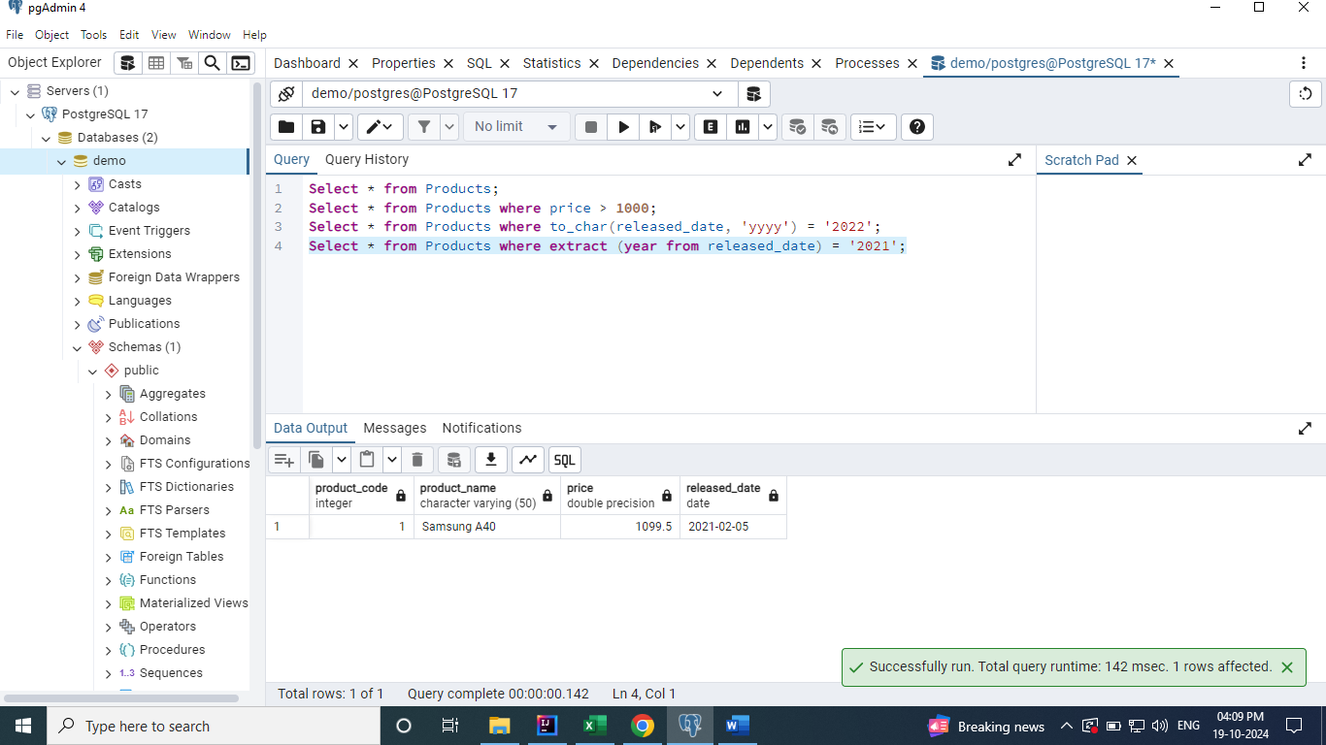

Using alias when retrieving the data from the Products table. ‘As’ keyword is used for alias. We can use it for both the columns and tables.

**Select product_name as Product_model from Products where price > 1000;**

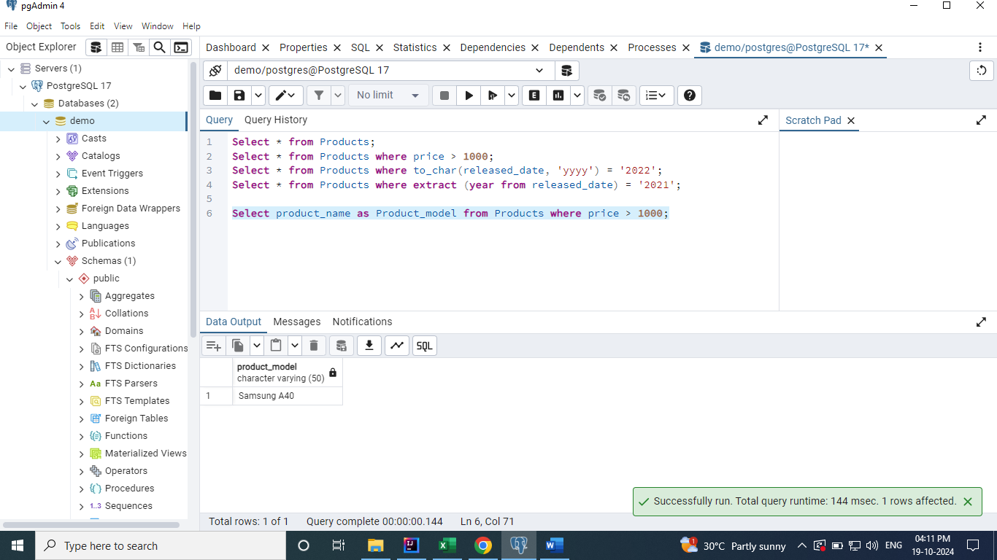

**Aggregate Functions**

Count, Sum and Avg.

**Count –** It is used to get the total number of records present in the table.

**Select count(*) from Products;**

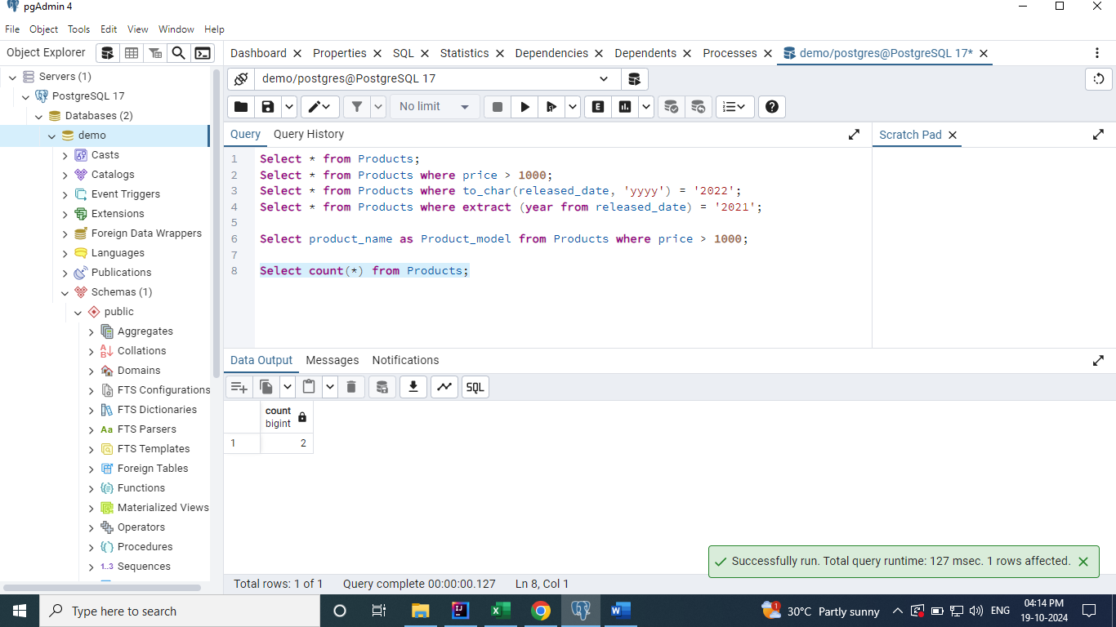

**Sum -** It is used to sum up the all the values in a particular column.

**Select sum(price) from Products;**

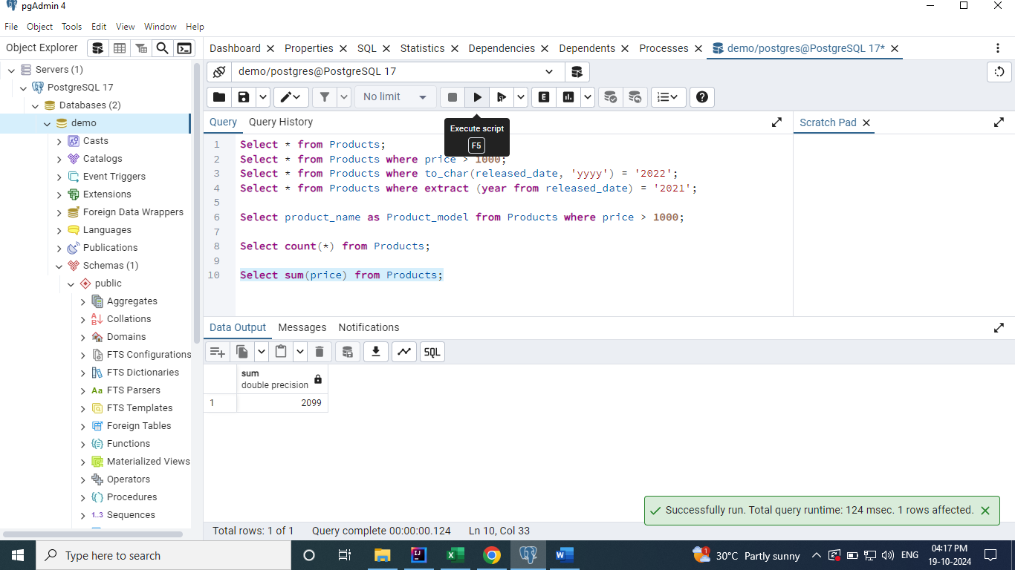

**Avg -** It is used to sum up the all the values in a particular column and find the average of it.

**Select avg(price) from Products;**

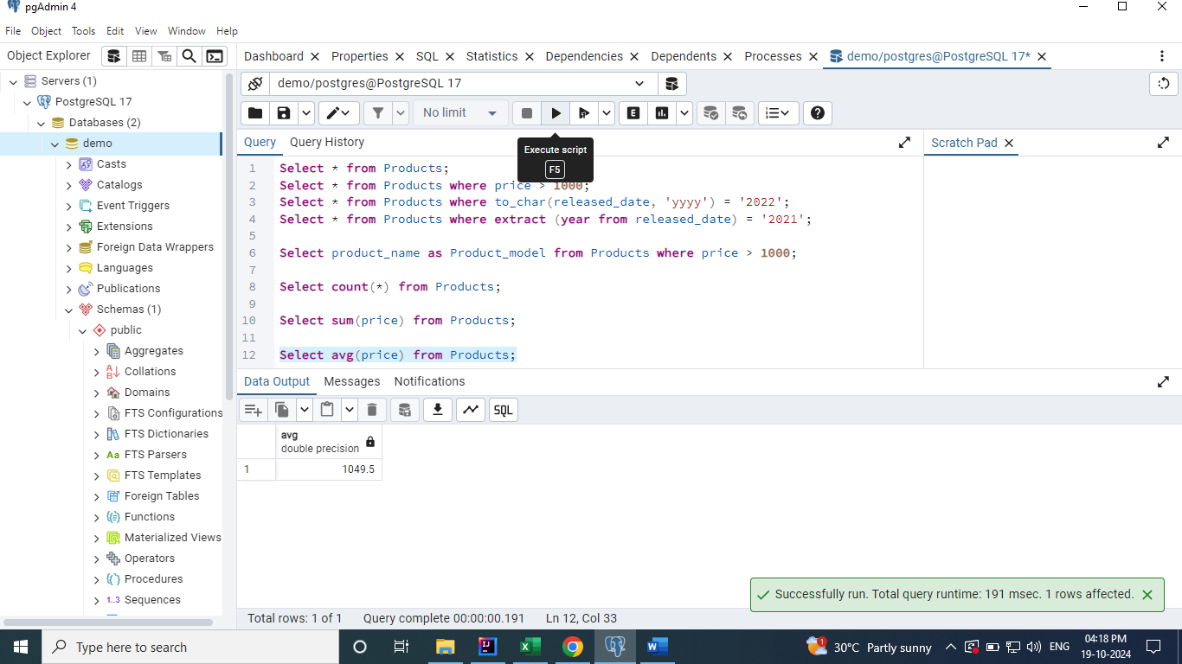

**Update Operations**

Here, I have used the update keyword to update the table records.

Updated one of the records of products table by using the where clause. If the where clause is NOT

used in the update statement, then the update operation will be applied to all the records.

**Update Products set price = 1000 where released_date = to_date('25-07-2022', 'dd-mm-yyyy');**

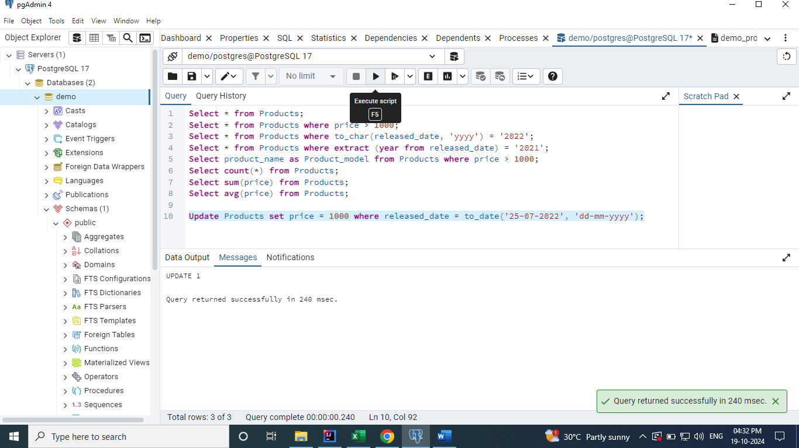

After update

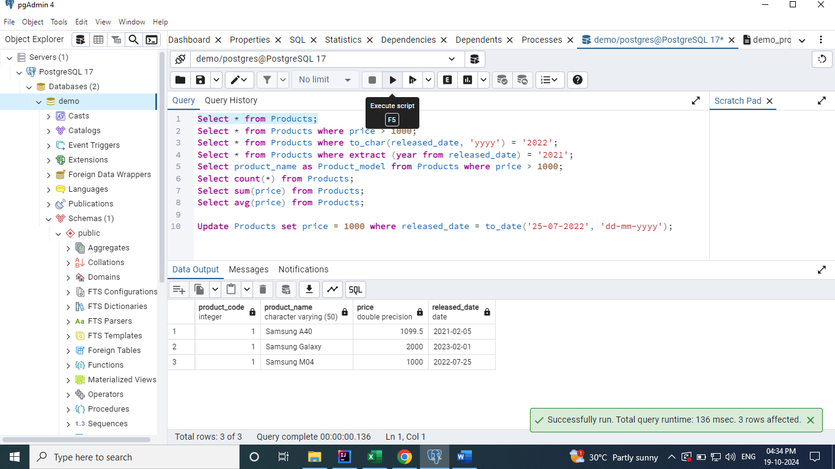

**Using Like Keyword**

**We can use the like keyword to update the records. The like operator can be used in below ways.**

**Like value%** - Ends with value

**Like %value** - Starts with value

**Like %value%** - Anywhere the value lies.

**Update Products set price = 2599 where product_name like '%Galaxy';**

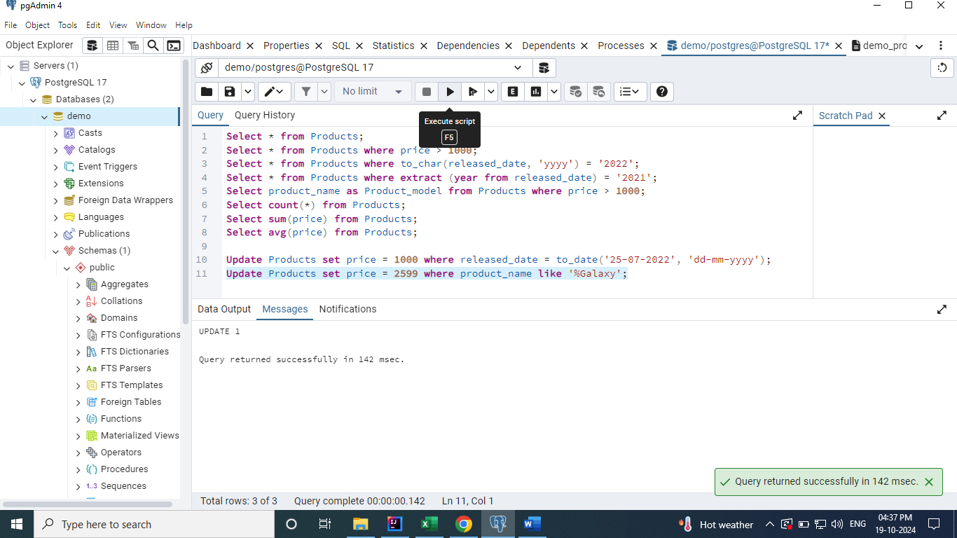

After Update

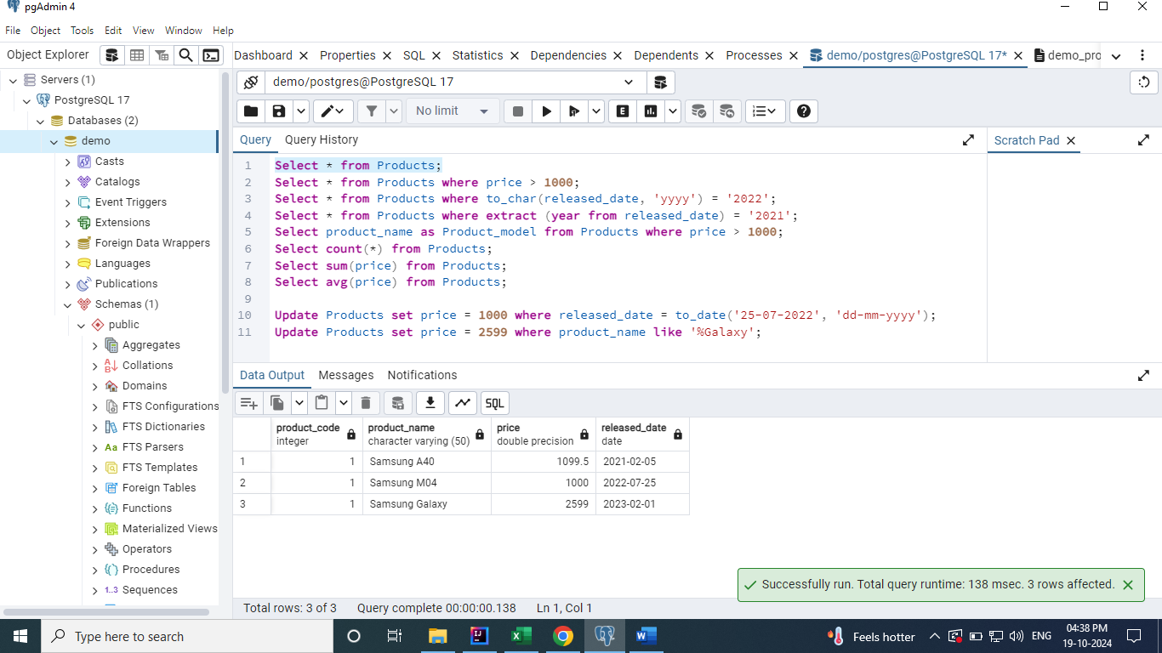

**Not Like keyword**

It behaves exactly the reverse of the like keyword.

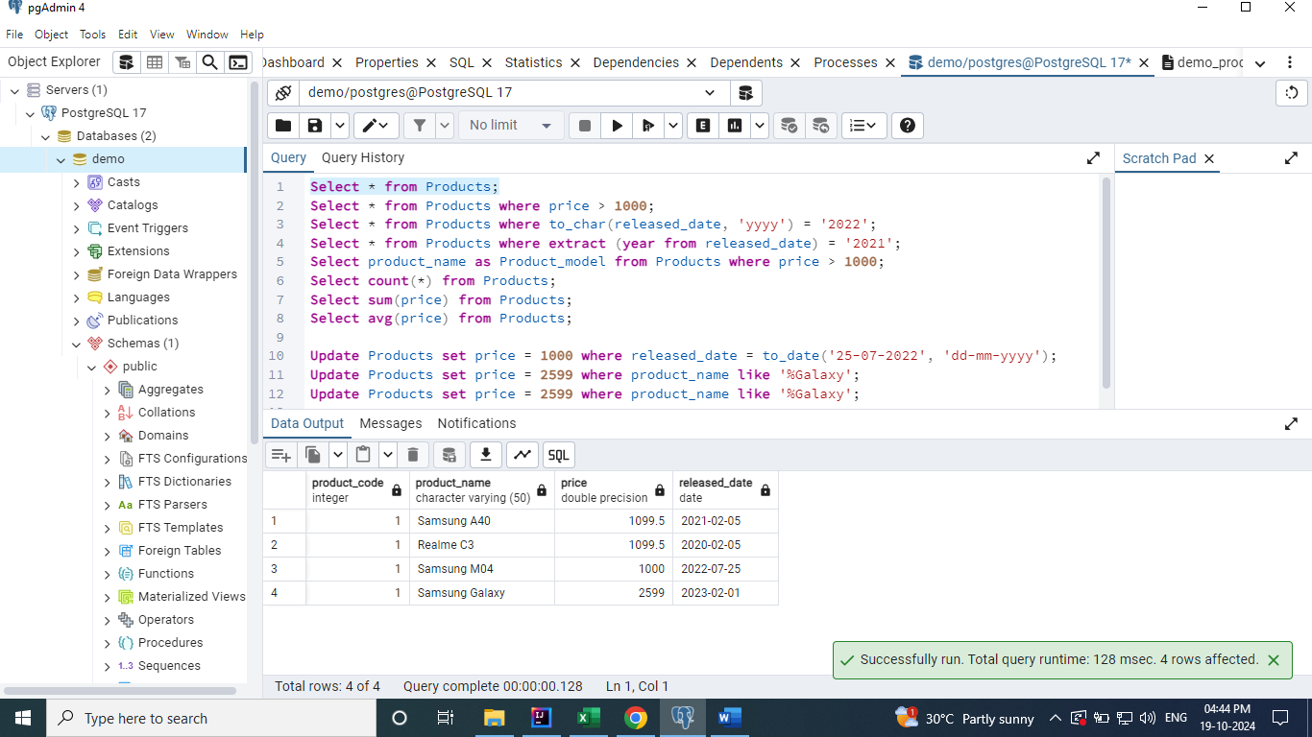

The below query updates the Realme row’s price.

**Update Products set price = 1100 where product_name not like '%Samsung%';**

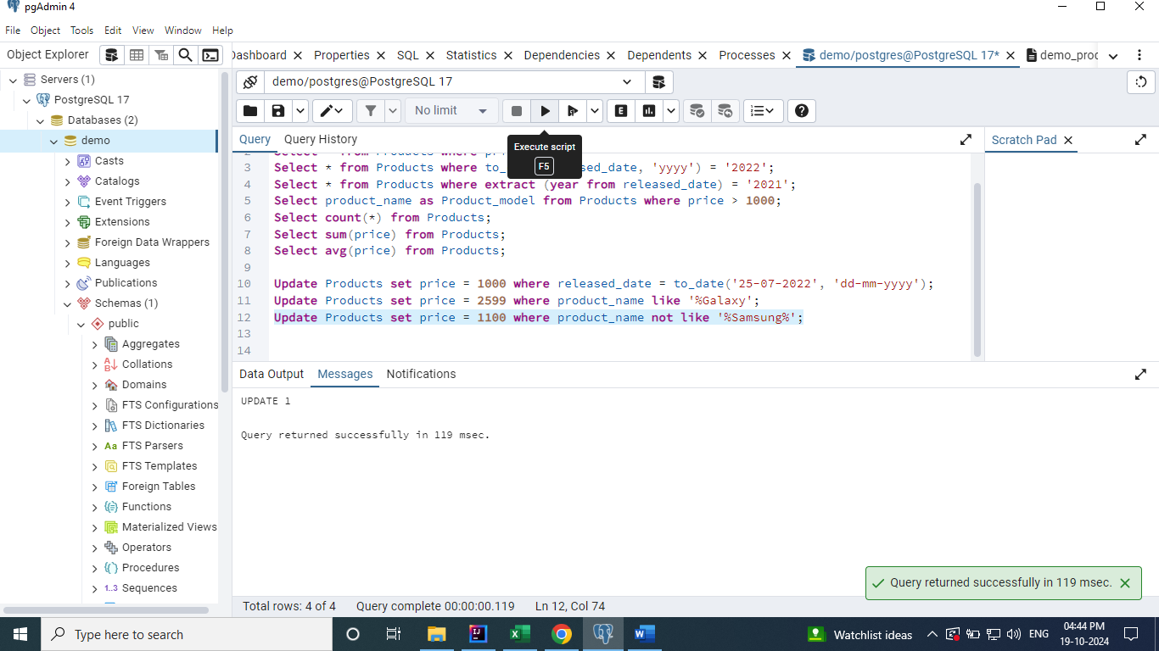

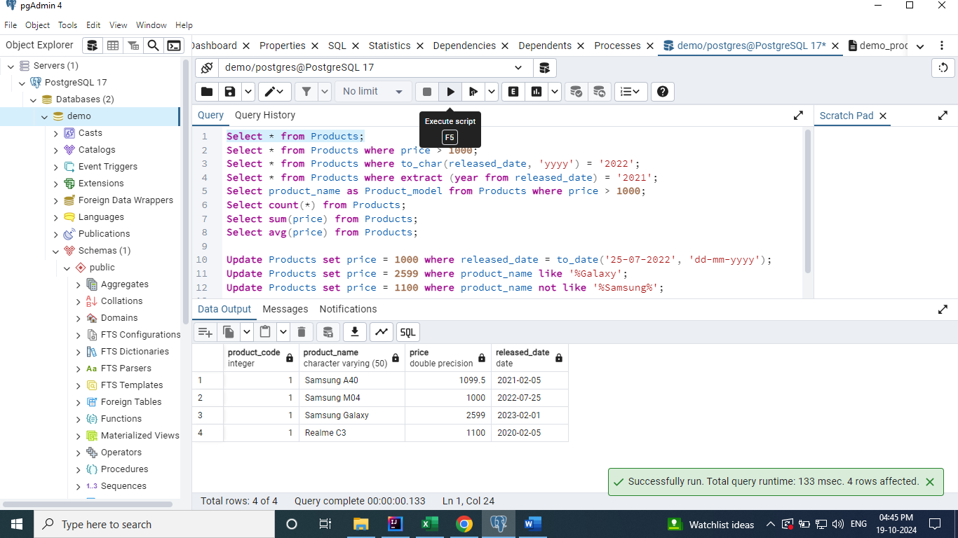

**Delete Operations**

Here, I have used the delete keyword to delete the table records.

Deleted one of the records of products table by using the where clause. If the where clause is NOT

used in the delete statement, then the delete operation will be applied to all the records.

**Delete from Products where price = 1100;**

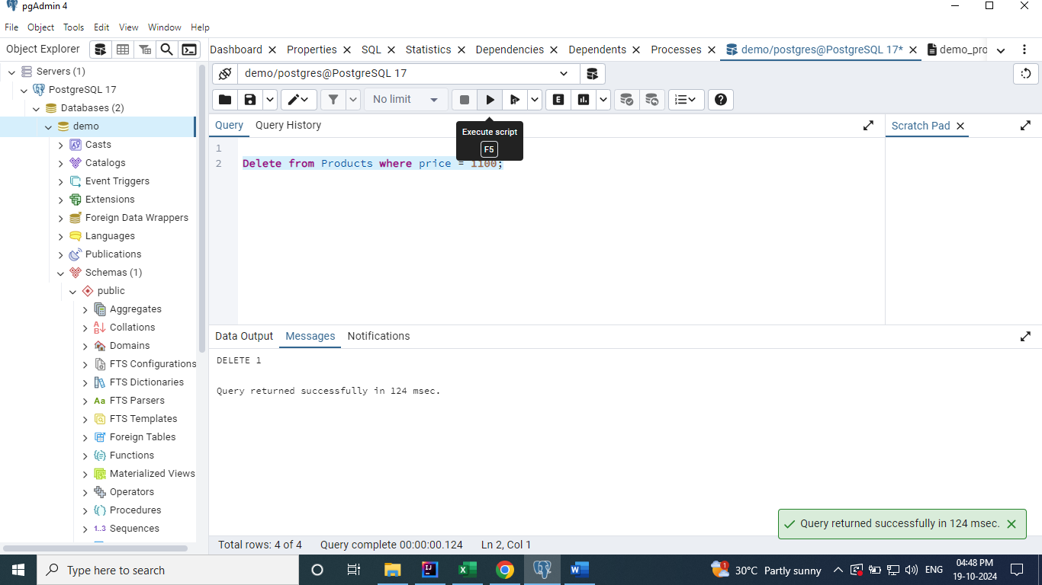

After Delete

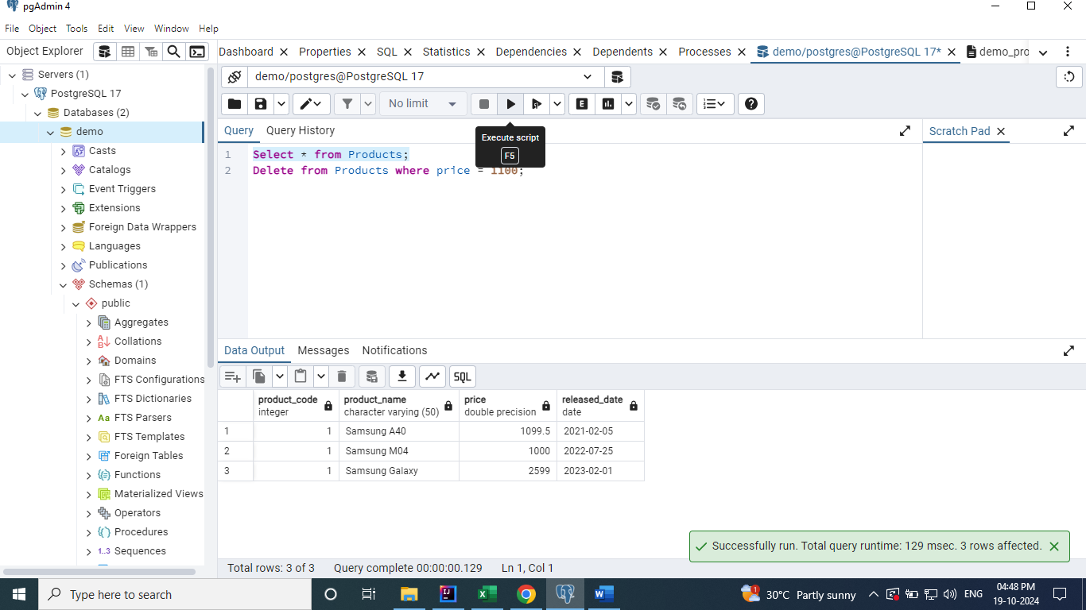

**Delete all the records from Products**

**Delete from Products;**

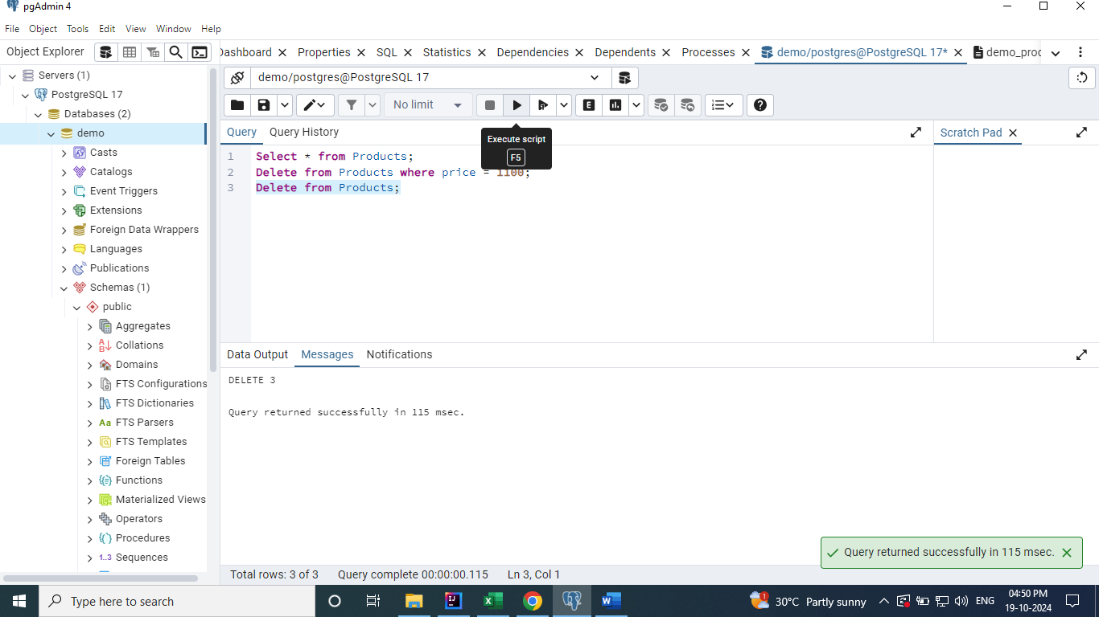

**Truncate – It is used to delete all the records from the table and its very fast than the delete keyword.**

**Truncate table products;**

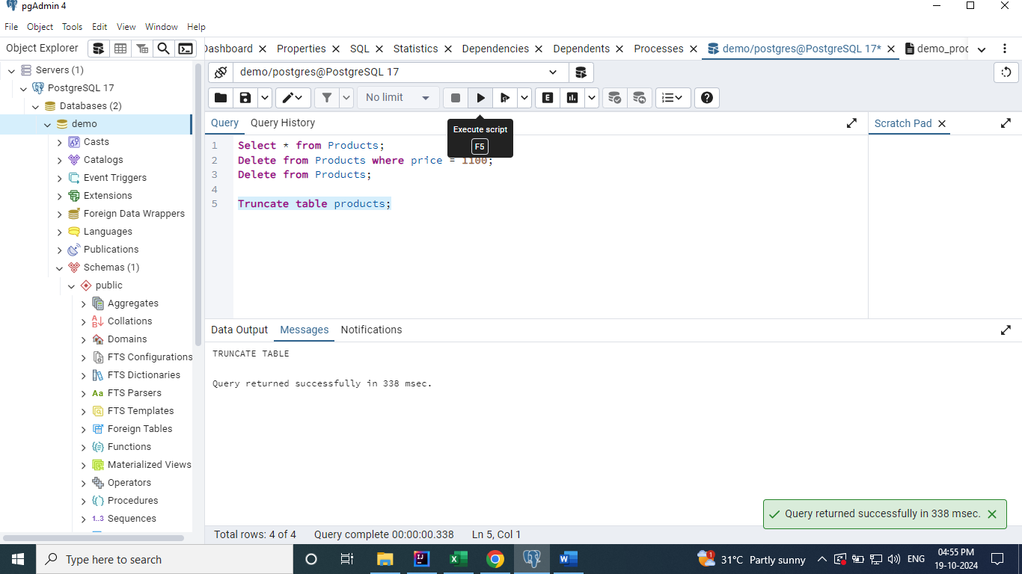

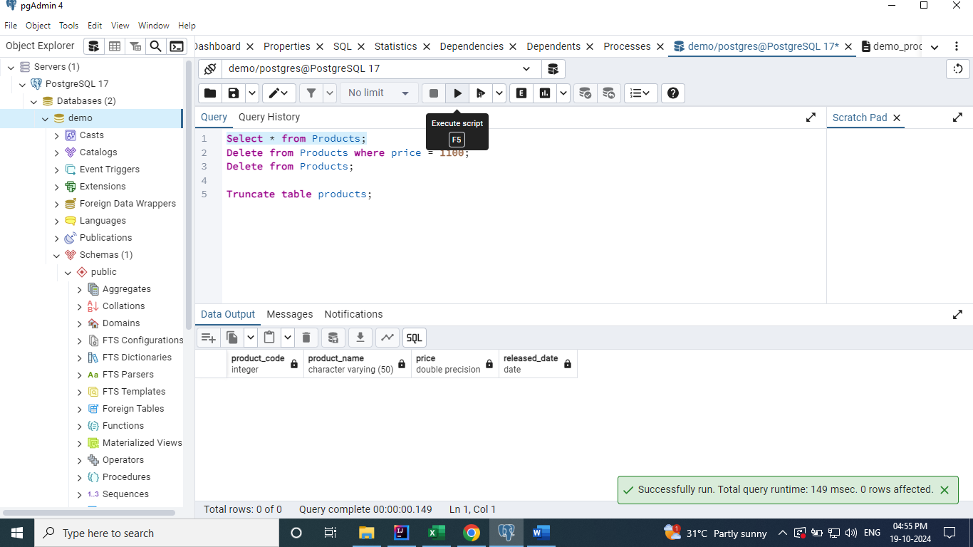

**Backup Table**

When we want to create the backup of table, then we can create it 2 ways as below.

1. Copy the content and structure of the table.
2. Copy the structure of the table ONLY. [ We have to provide the False condition Where clause]

**Create table products_backup as select * from products;** (Copy the content and structure of the table.)

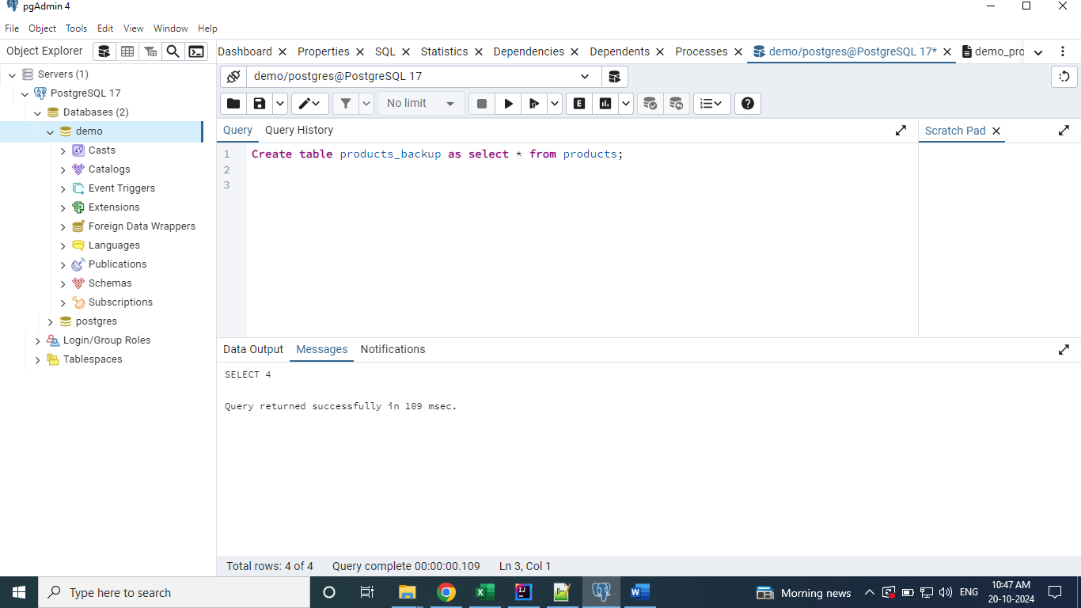

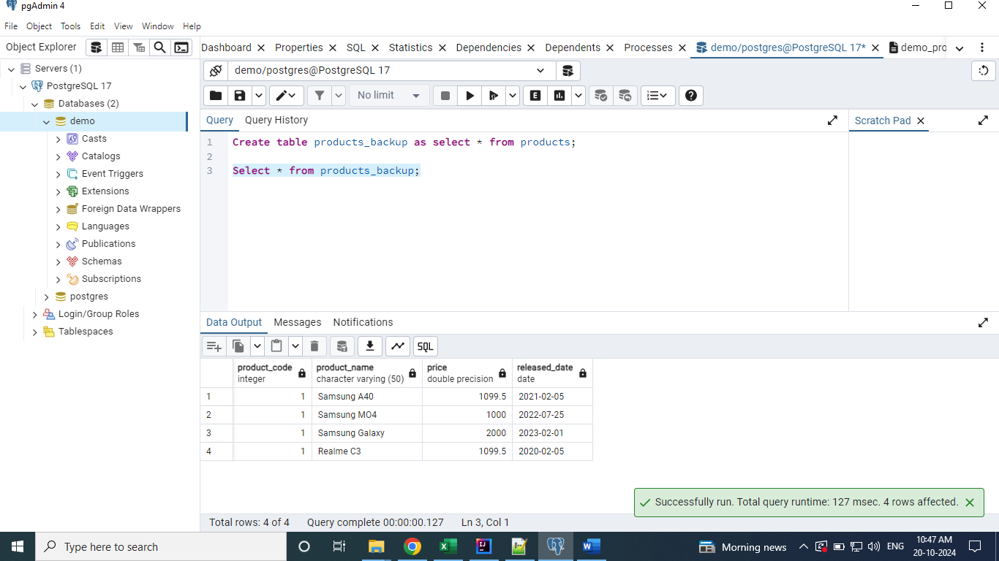

**Create table products_backup2 as select * from products where 1 = 2;** (Copy the structure of the table ONLY.)

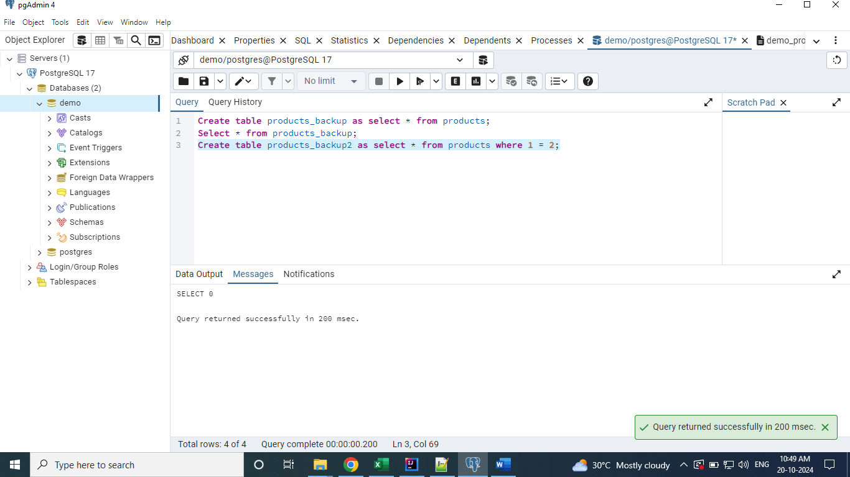

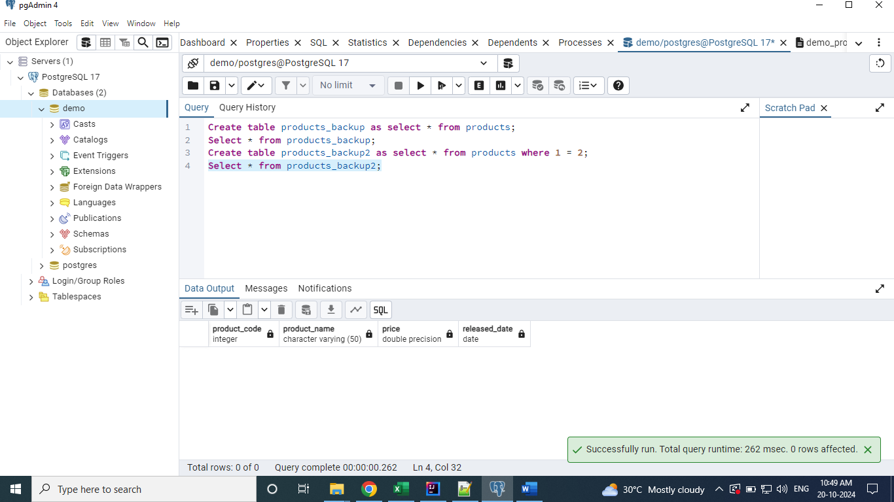

To remove the Table completely from Database. We have to use the Drop keyword.

**Drop table products_backup;**

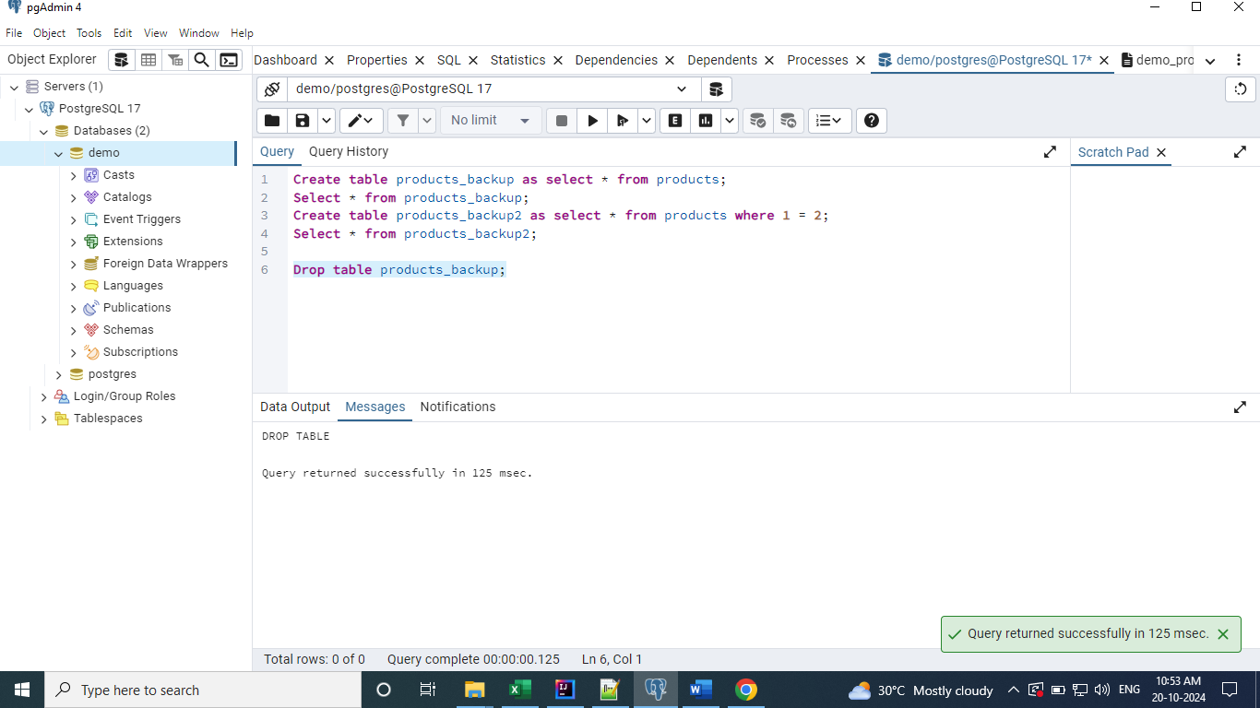

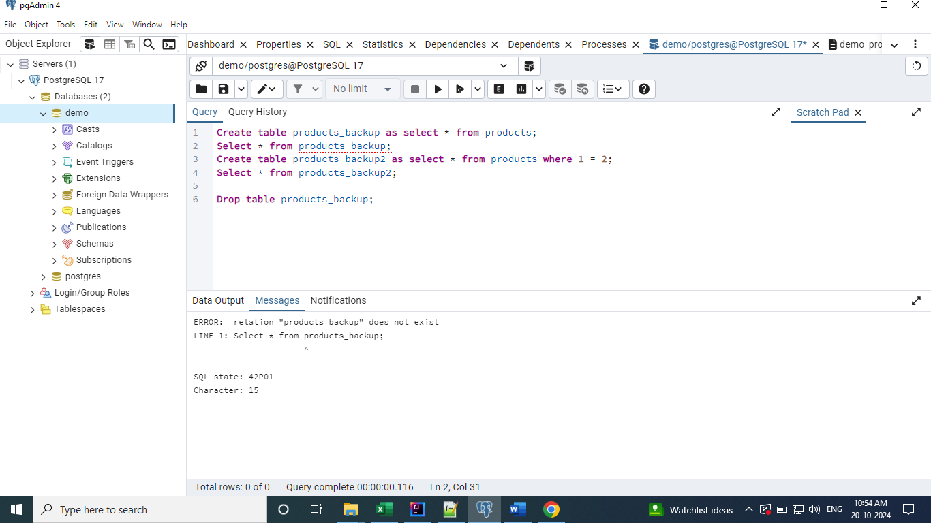

Check for the presence of the table and drop it.

**Drop table if exists products_backup2;**

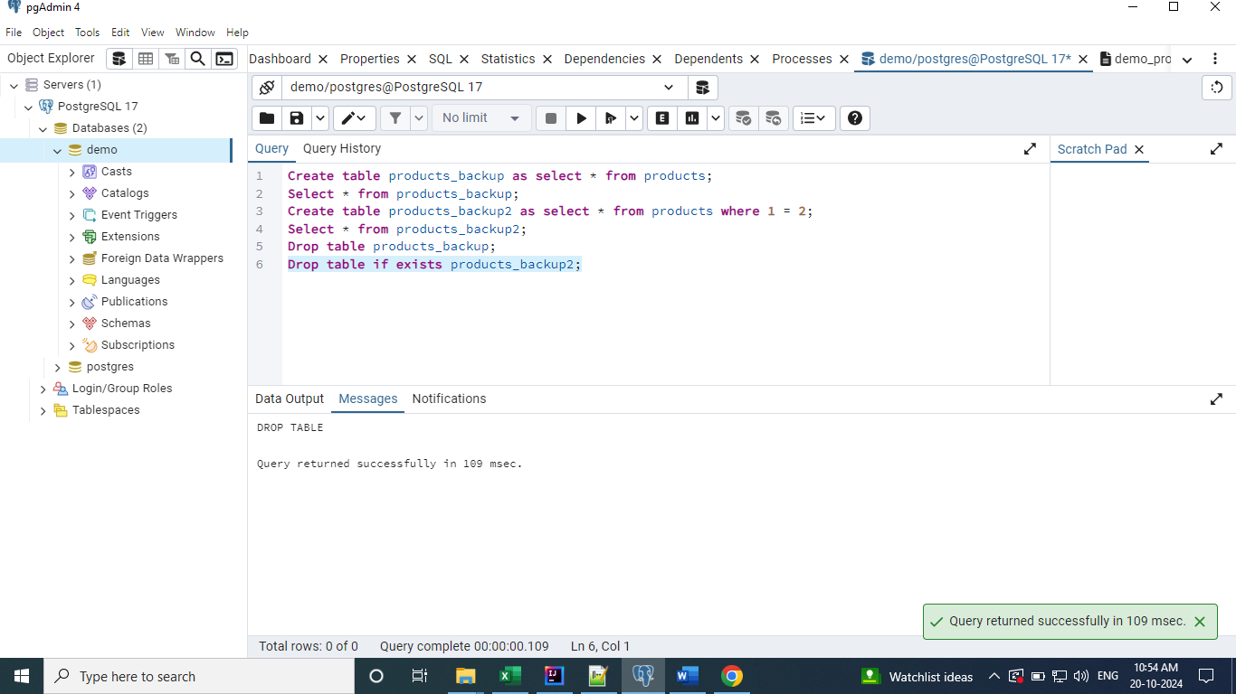

**Modify Operations [Alter]**

Renaming a table using alter command.

**Alter table products_backup rename to products_bkp;**

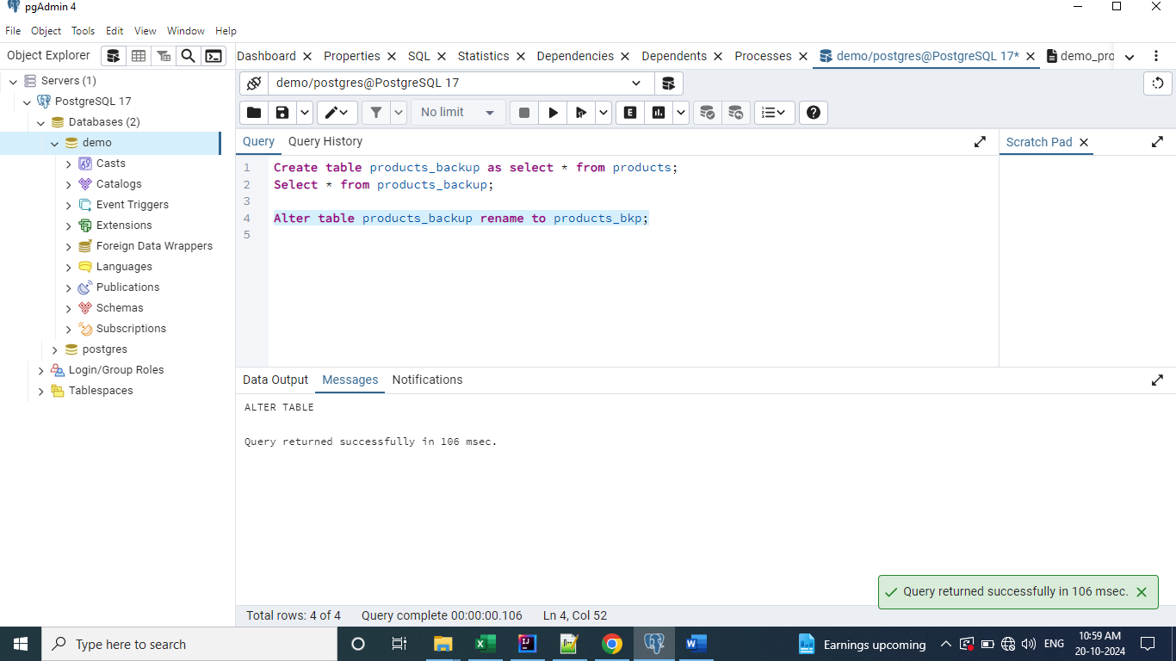

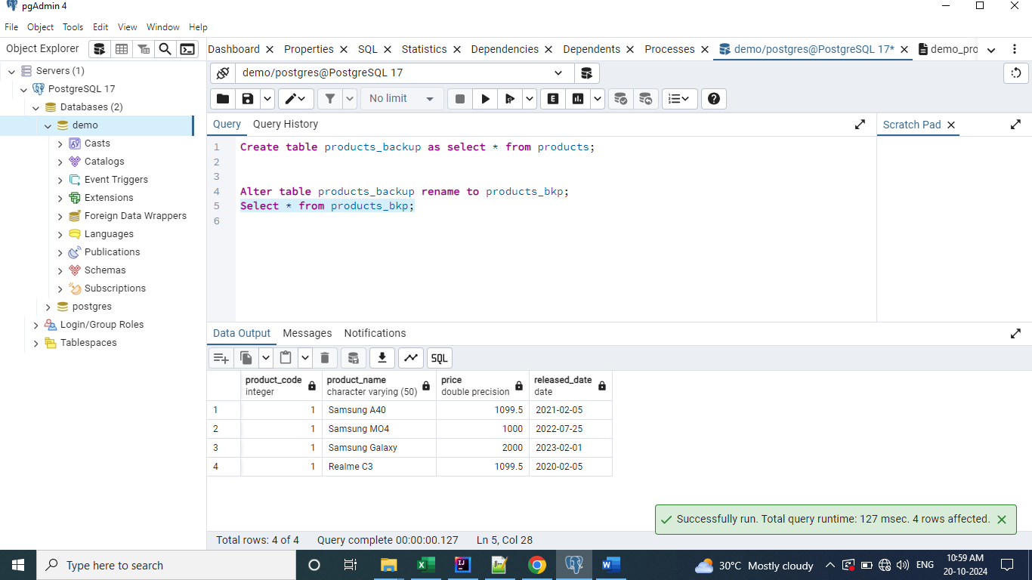

Alter the table column name.

**Alter table products_bkp rename column product_code to product_id;**

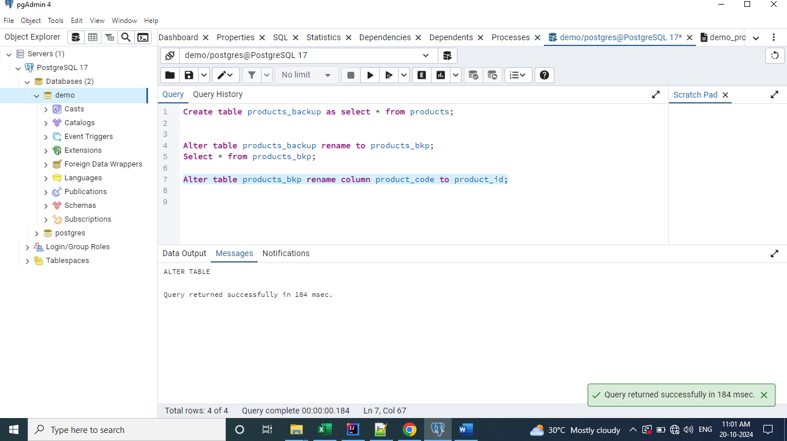

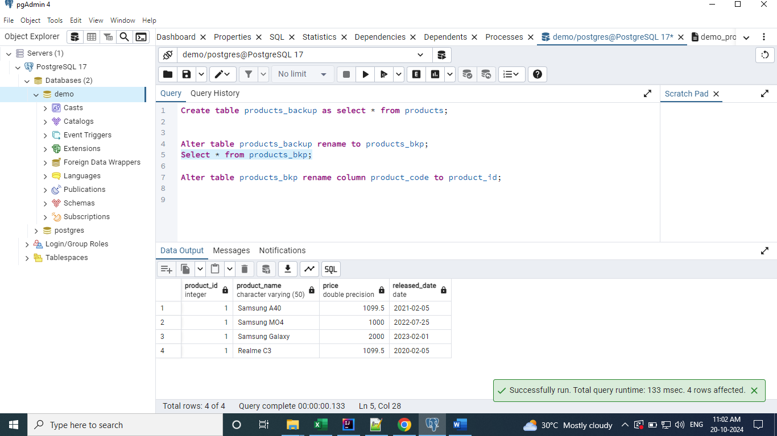

Alter the table column data type.

**Alter table products_bkp alter column product_id type varchar(10);**

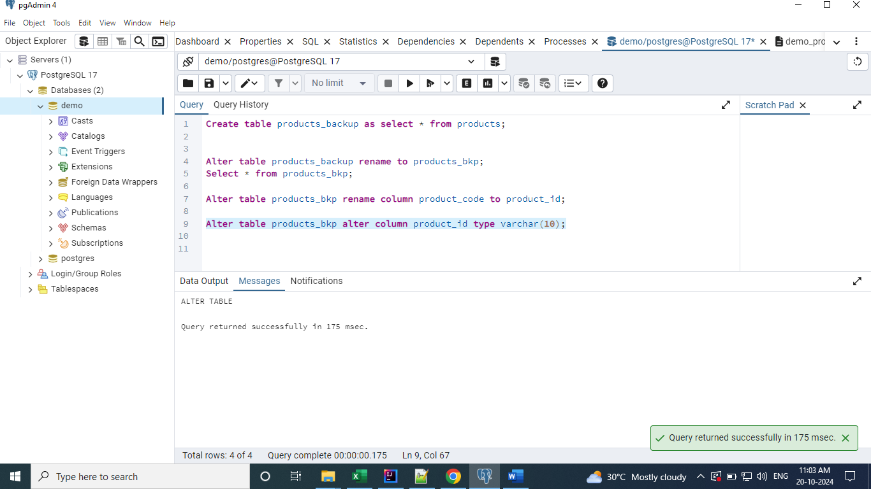

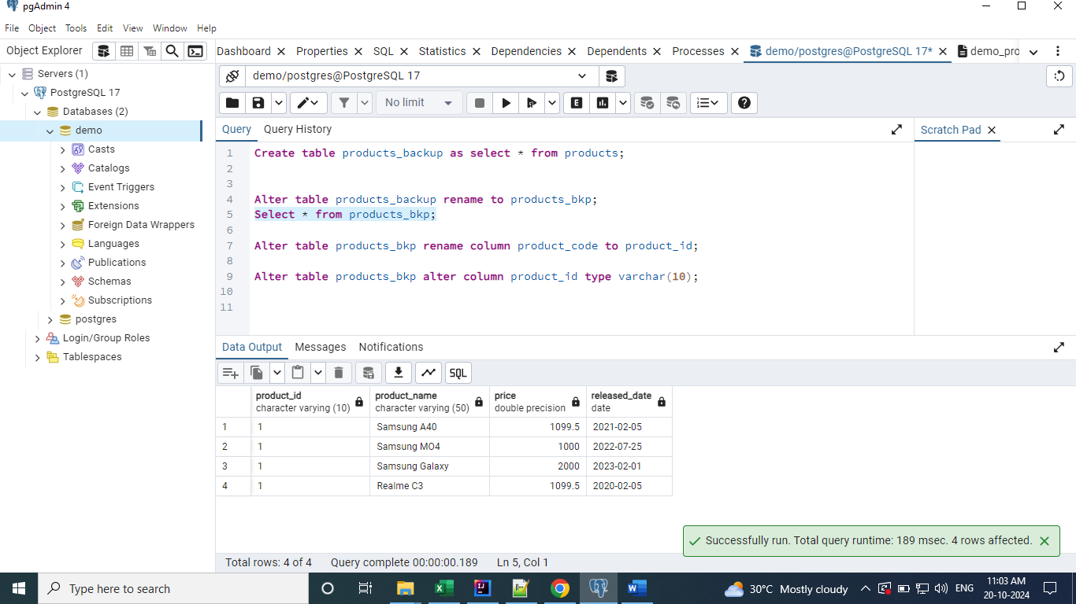

**Constraints**

Constraints are some kinds of restrictions applied to the columns of the table. Restrictions added to have non-redundant data, meaningful data and correct date inserted into tables.

Primary Key – Used to have the values as not null and unique values.

Created a table with Primary Key constraint.

**create table products (**

**product_code int primary key,**

**product_name varchar(50),**

**price float,**

**released_date date**

**);**

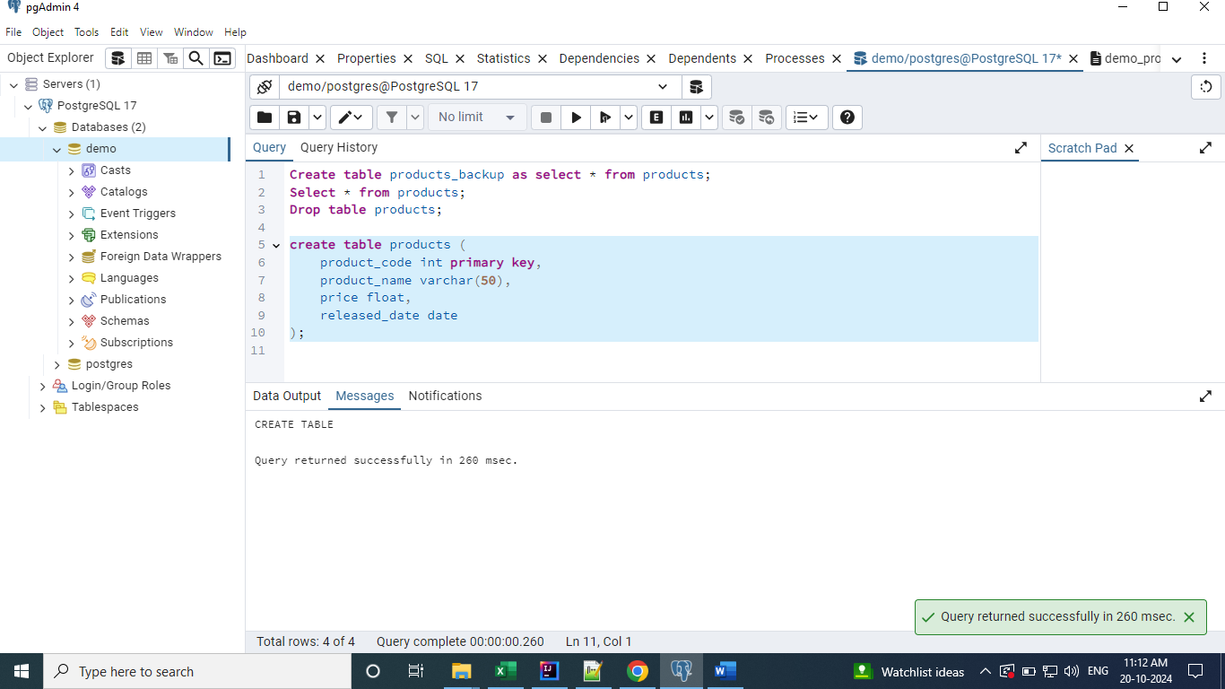

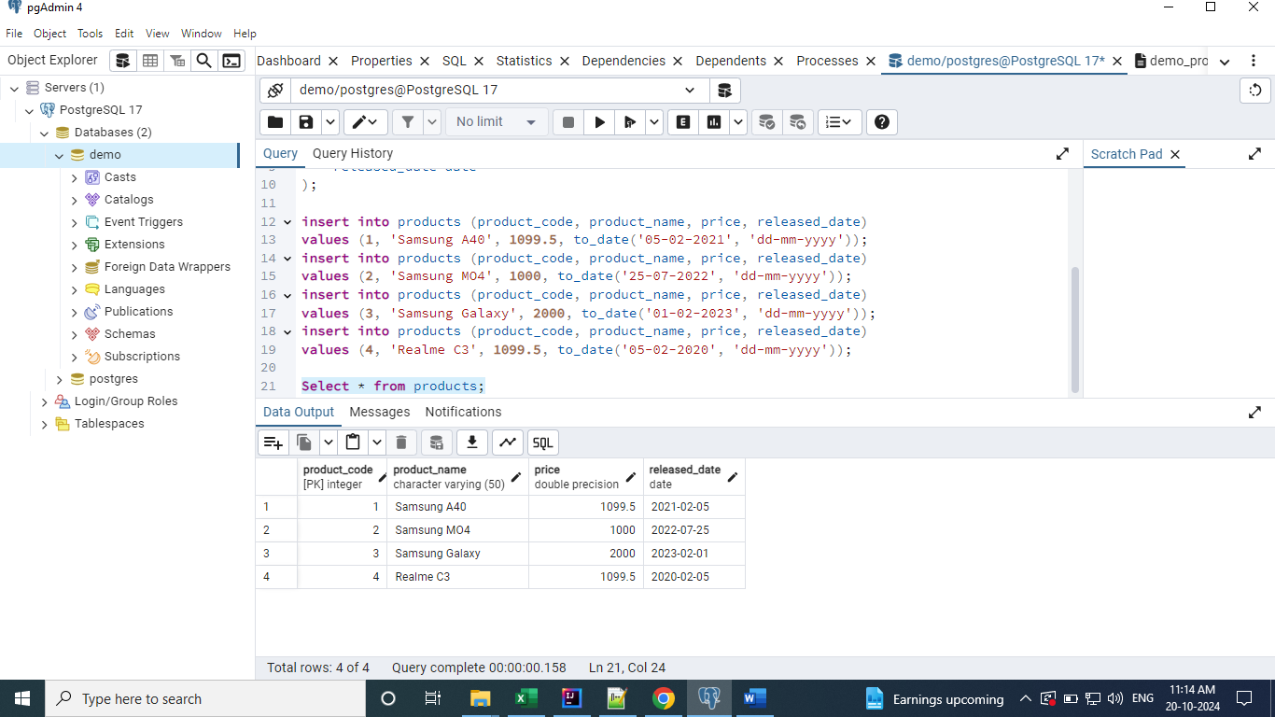

Throwing error when record with duplicate key is added.

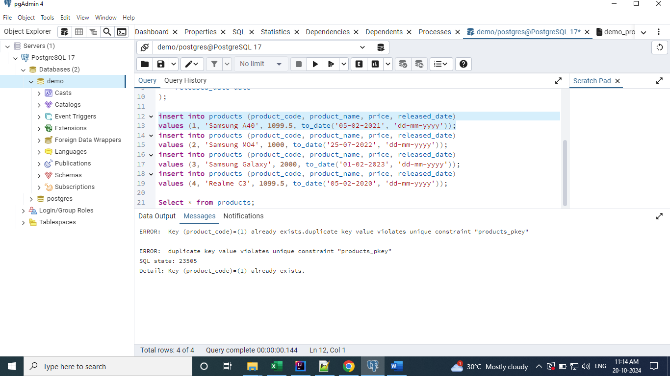

Throwing error when record with null value is added.

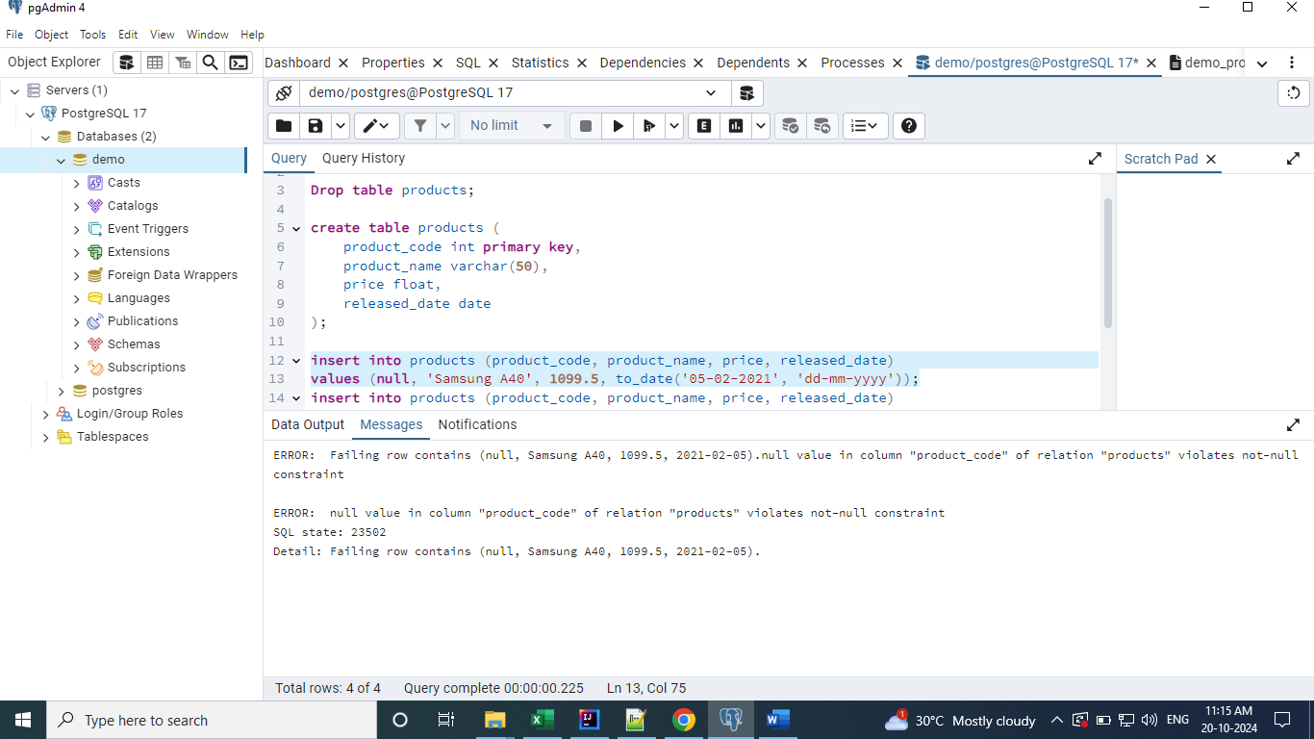

Another way of creating a table with Primary key.

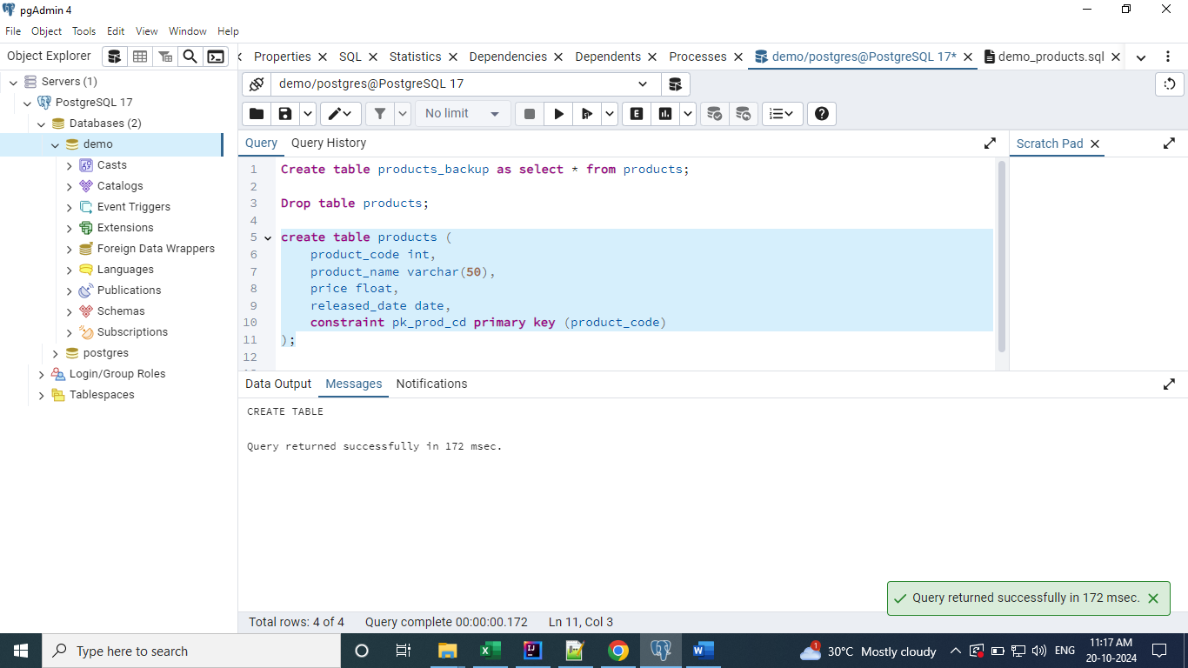

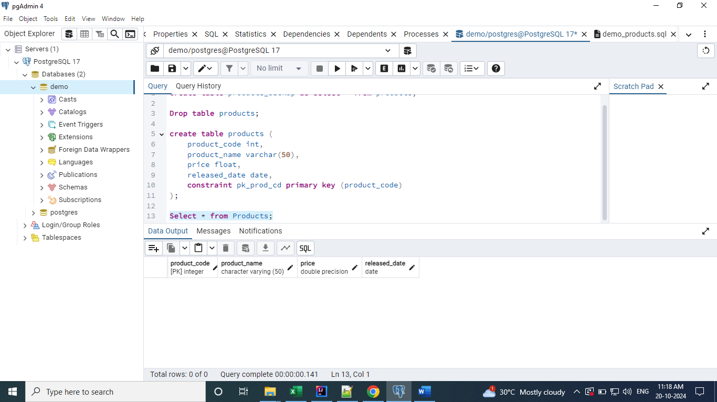

**Composite Primary Key**

When we create the primary keys for more than one column.

We can’t create the Composite Primary Key using the first approach of Primary Key addition to the table. It will not be allowed and error is thrown.

We have to use the second approach of Primary Key addition to the table to create the Composite

Primary Keys.

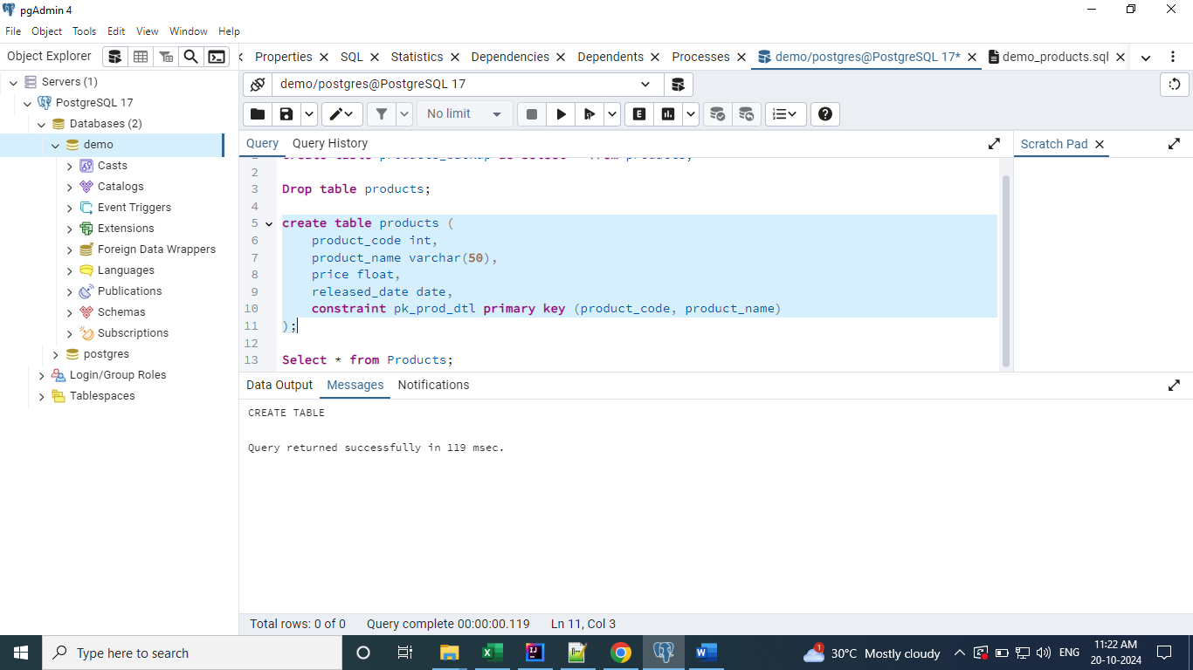

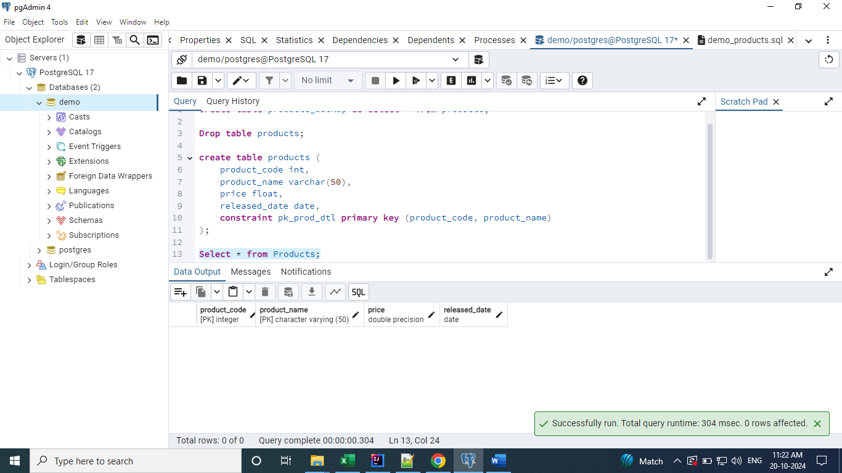

**Identity constraint**

Let’s say we have N number of records and adding the unique keys to those N number of records manually is hectic process. We can do that with the help of Identity key.

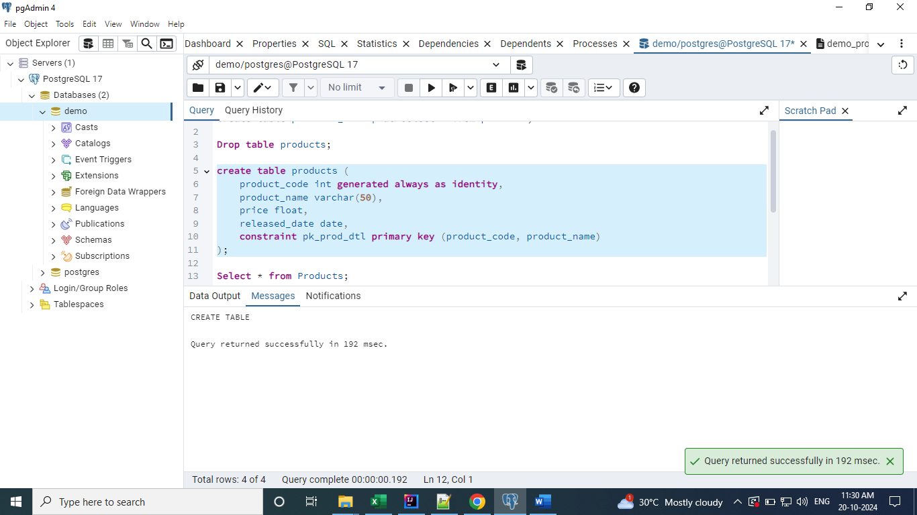

In the above table, we don’t need to enter the product_code manually. It will be automatically updated. If you try to enter manually then you will get the error.

We have to provide the ‘default’ value in place of product_code while inserting the records.

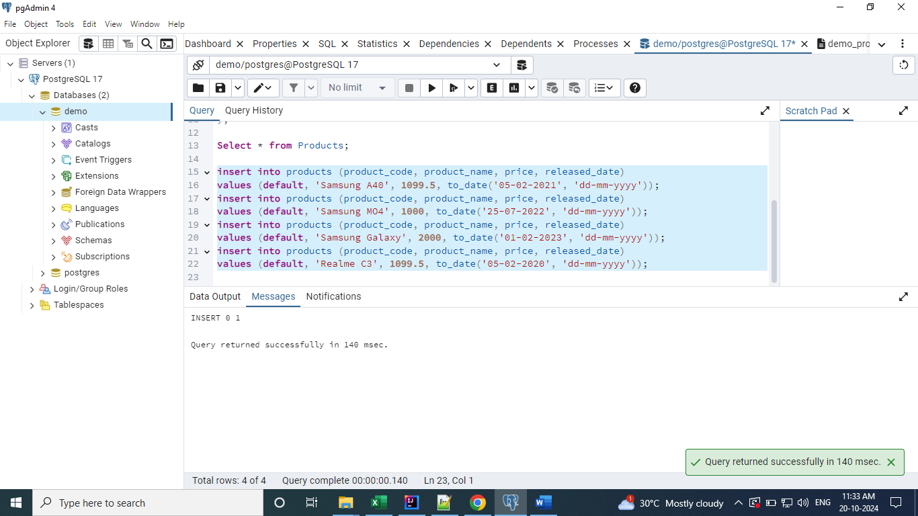

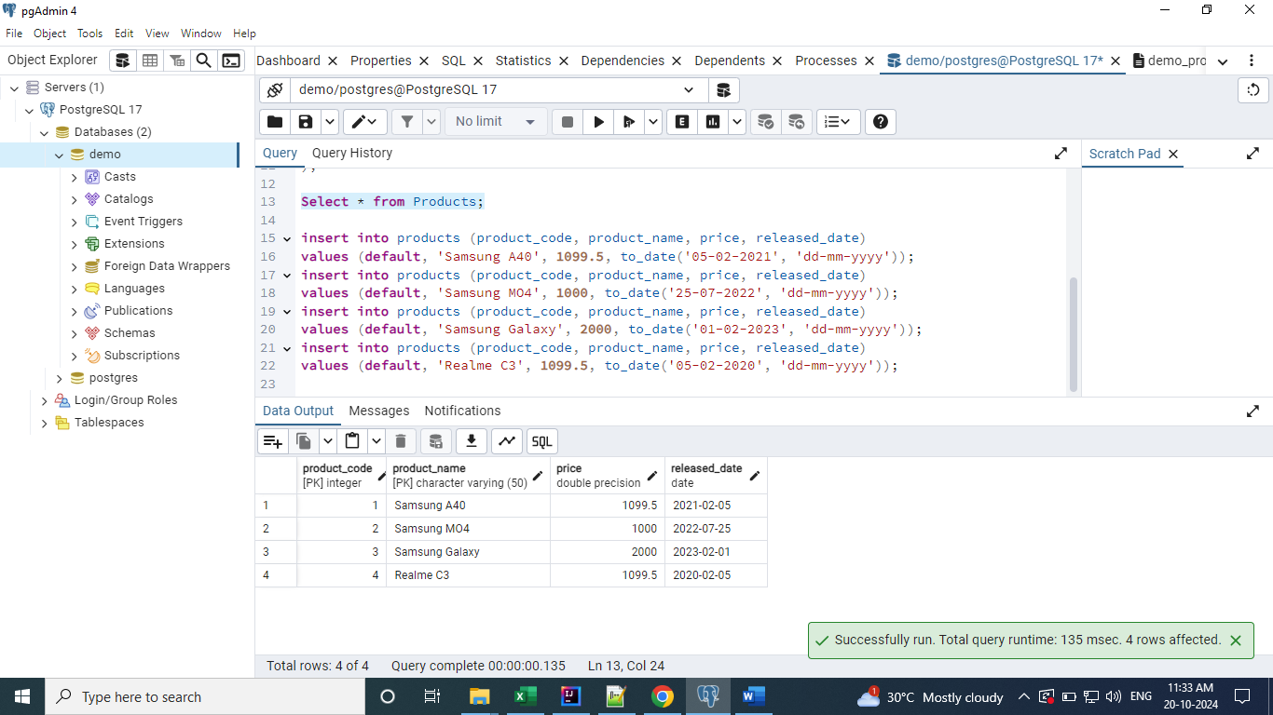

**Foreign Key**

To explain Foreign Key constraint, we need two tables. Created below Sales_Order table.

